

MY
HEALTH ACTION PLAN

INSERT PHOTO

Name: _________________________________________

Address: _______________________________________

_______________________________________________

Tel No: ________________________________________

Health Facilitator: | 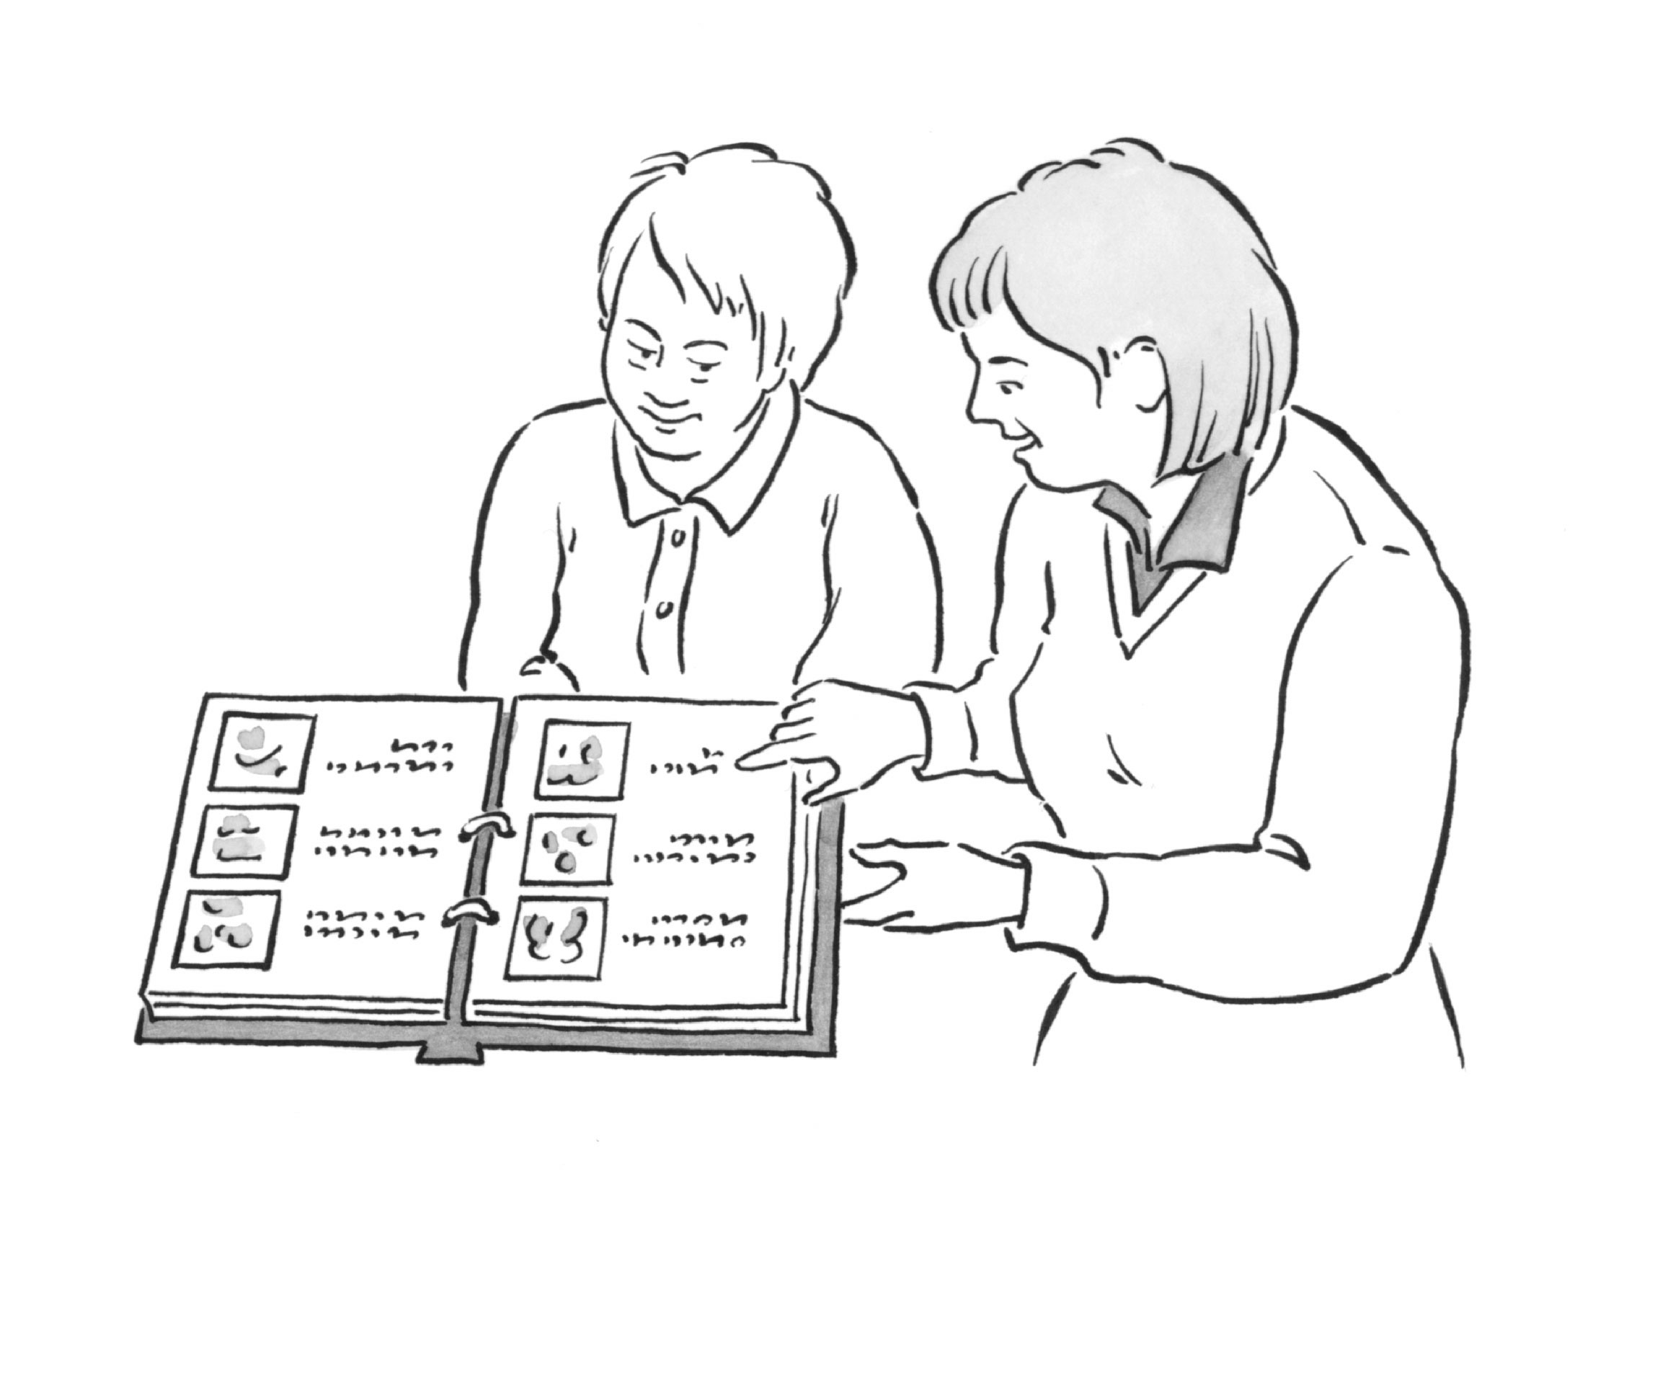
Telephone Number:

Telephone Number: | INSERT PHOTO

Designed by the ‘Staying Healthy Task Group’ Salford Learning Difficulties Team.

CONSENT TO SHARE MY HAP

This is my Health Action Plan.

I can make my own decisions on who I share it with – so please check with me if you want to read or add anything to my HAP.

I find it difficult to make decisions on sharing my HAP but the people who support me feel it is in by ‘best interests’ to share my HAP with all Health Professionals.

The people who have made this decision on my behalf are:

____________________________________________________________________________________________________________________________________________________________________________________________________________________

If you are not a Health Professional but would like to read or write in my HAP then please check this is in my ‘best interests’ first.

Please remember that my ability to make decisions can vary from day to day and will depend on the actual decision that has to be made. It is important that you give me as much help and support as necessary so that I am able to make as many decisions as possible. If I cannot make a particular decision then you must act in my ‘best interests’ as described in the Mental Capacity Act 2005.

CONTACT NAMES

Carers: |  | Tel:
Doctor:
Practice Nurse:
Others:

Health Action Plan Notes

HEALTH ACTION PLAN
Name:

Reason(s) for Health Action Plan:

 | Health Need | What needs to be done | Who will help | The outcome
Continued: Yes / No

Suggested / Approved by______________________________(Name of health worker) Role:_____________________________

Start date:___________________ Review dates: ________________________________________End date:________________

