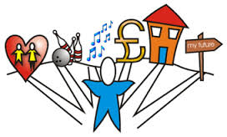MY PREPARING FOR ADULTHOOD TRANSITION PLAN
Name |  |  |  | Date of first plan |  |  |  | Plan number
My Goals  What we are trying to achieve |  |  | Action  What needs to Happen to help me achieve my goals |  |  | Who  Who needs to it | By when |  | Comments  How we doing

PREPARING FOR ADULTHOOD TRANSITION PLAN: THINGS WE NEED TO THINK ABOUT:
Below are some the things you might need to do, or skills you might need to learn to help you become more independent and get ready for being an adult
Money | Health and safety | Being part of my community | Work and learning | Home and where I live | Develop self care | Develop life skills | Getting the support I need
 | 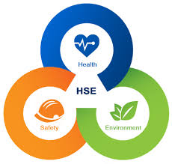 | 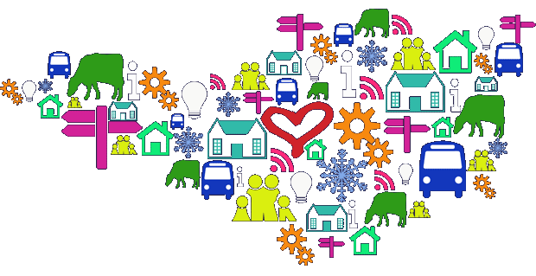 |  |  | 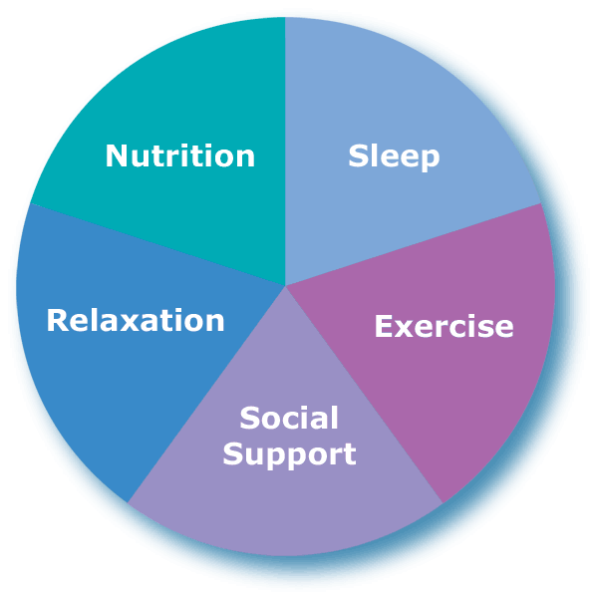 | 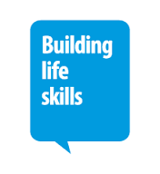 | 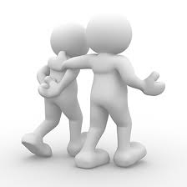
Have I got a bank account and do I know how to use the bank | Do I understand how to make a medical appointment? | Can I travel independently and plan a journey | What do I want to learn? | Can I stay in my home on my own and be safe – what needs to happen to support me with this | Can I prepare healthy meals | Can I plan and cook a simple meal safety | I know where to get help and support from
Can I go to the shop and buy things using a list | Do I know how to maintain my general health | Do I access any social groups or community groups | What job do I want | Can I keep my room tidy | Do I take enough exercise | Can I communicate my needs | I need extra help from social services
Do I need to learn budgeting skills | Do I understand by health conditions | Do you want to volunteer | What job skills do I need to learn | Do I help with household chores | Do I have issues with my anxiety and need to learn to manage this better | Can I make decisions about my life | I need to work with my social worker to think about what I am good at and what I need help with
Do I understand money | Do I need any support around sex education or sexual health | Can you get around your local community | What will I do once I leave college | Where do I want to live post 18 | Do I have ways to relax | Can I look after my personal care | I need to learn about who can help me as an adult
Do I need to claim benefits / do I understand what benefits I am entitled to? | Doing I understand the dangers of drugs and alcohol | Being a good neighbour | What I am good at, what do I struggle with | What I need to learn to become independent | Do I sleep well
Can I pay bills | Do I need support with internet safety | Do I understand stranger danger |  | Can I manage my own front door
Do I understand the value of money? | Do I need to learn how to stay safe in the community

