Appendix A: Understanding Need

1. Salford - as of 31 December 2020 there were:

Total number of care leavers: 249 young people
Total number of children who are categorised as children in need, or subject to child protection plans: 1,585
Total number of CYP on child protection plans: 447
Total number of Looked after children: 540
Data source: CareFirst, SCC

For comparative data across all local authorities in England: Local authority interactive tool (LAIT) - GOV.UK (www.gov.uk)

2. Equality and 0*-25 in Salford: December 2020 overview of the 0-25 population:

3. Crisis Care Pathway: December 2020 data review

4. SEND in Salford - as of 31 December 2020 there were:
Salford SEND Strategy

Infographics from Salford SEND strategy 2019:
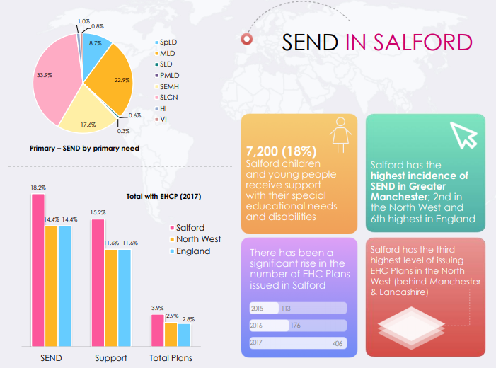

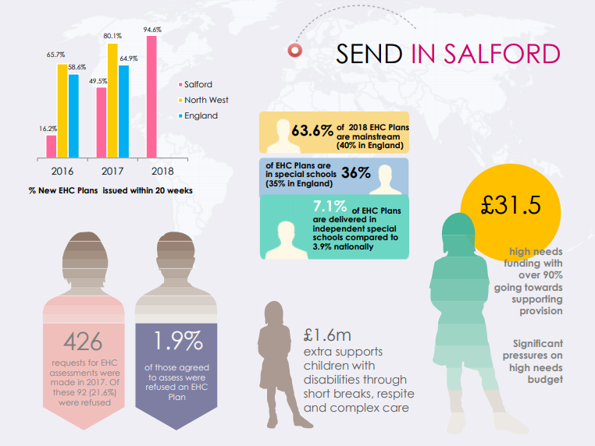
Salford is the 18th most deprived local authority in England/3rd in GM with (30.4%) of people living in deprivation, equating to 21% of children in families living below the poverty-line (up to 52% in one neighbourhood). The impact of this is evident across the education system.
SEMH need in Salford: Salford has the highest incidence of SEND in Greater Manchester, 2nd highest in the NW, 6th highest in England. Of those children with SEN, 19.5% have an identified SEMH need (16.25% nationally), see below table.
School Populations 2019/20 | England | Manchester | Oldham | Rochdale | Salford
Reception | 633,499 | 7,202 | 3,370 | 2,963 | 3,051
Year 1 | 638,389 | 7,099 | 3,418 | 3,021 | 3,068
Year 2 | 651,934 | 7,346 | 3,574 | 3,113 | 3,214
Year 3 | 667,470 | 7,318 | 3,453 | 3,165 | 3,180
Year 4 | 667,315 | 7,337 | 3,627 | 3,077 | 3,221
Year 5 | 655,472 | 7,330 | 3,605 | 3,060 | 3,156
Year 6 | 644,348 | 7,215 | 3,628 | 3,103 | 3,027
Year 7 | 639,673 | 6,482 | 3,597 | 2,820 | 2,567
Year 8 | 615,634 | 6,379 | 3,393 | 2,814 | 2,527
Year 9 | 595,432 | 6,316 | 3,337 | 2,647 | 2,380
Year 10 | 583,560 | 5,806 | 3,246 | 2,691 | 2,418
Year 11 | 566,674 | 5,583 | 3,167 | 2,572 | 2,333
Year 12 | 221,392 | 983 | 528 | 112 | 129
Year 13 | 192,557 | 695 | 473 | 121 | 144
Year 14 | 4,801 | 51 | 33 | 28 | 29
Data source: Explore-education-statistics.service.gov.uk

