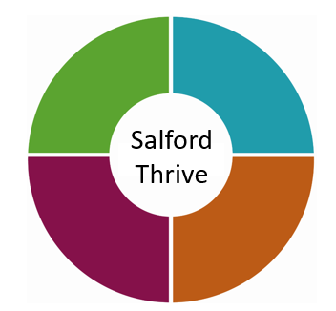

Salford Thrive Plan

2022

**Annual Update**

**March 2022**

**Final version**

**Contents Page**

|  |  |  |
| --- | --- | --- |
| **1** | Executive Summary | Page 4 |
| **2** | Introduction | Page 5 |
| **3** | KLOES | Page 6 |
| **4** | GM CYP Mental Health Plan: 2020-21 update | Page 7 |
| **5** | Our Ambitions:  Ambition One  Ambition Two  Ambition Three  Ambition Four  Ambition Five  Ambition Six | Page 8 |
| **6** | Finance and Investment | Page 36 |
| **7** | Performance, Outcomes & Service Data | Page 37 |
| **8** | Priorities for 2021-22 | Page 43 |
| **9** | Key References / Links | Page 44 |
| **10** | Appendices | Page 44 |

Foreword

Salford has had a shared vision to improve Children and Young people’s Emotional Health and Wellbeing since 2015, and despite a Global Pandemic and a global trauma for everyone, significant work has progressed in Salford to mitigate some of the widespread impacts we know will have been experienced. Research on the mental health consequences of the Covid-19 pandemic is still quite limited. [A rapid review of international studies](https://www.ncbi.nlm.nih.gov/pmc/articles/PMC7363598/) showed an increase in depressive and anxious symptoms in children as a result of Covid-19. This is likely attributable to a wide range of factors, including:

* social isolation;
* anxiety about illness;
* uncertainty about the future; and
* strained familial relationships.

Similar conclusions were drawn [by a second international review](https://www.ncbi.nlm.nih.gov/pmc/articles/PMC7323662/), with the authors noting that any international disaster constitutes a form of trauma, and children living through Covid-19 should be considered at elevated risk of developing post-traumatic stress disorder. The pandemic may also have increased health anxiety in young people, encouraging a preoccupation with infection and current global state will create ongoing uncertainty. Further global developments including the war in Ukraine, undetected need from the lockdown period and new and emerging issues for young people will impact on their ability to maintain mental wellbeing.

Therefore, we still have much to do to and we want to ensure this generation’s mental wellbeing is acknowledged, responded to, and that we have the right support at the right time from the right people. We also want to provide hope and post traumatic growth for our children and young people by strengthening the preventative and supportive interventions we put in place. We are developing mental wellbeing champions in each sector in Salford to support us with this agenda. We wish to develop a trauma responsive system in Salford to equip our communities, professionals and care givers with the knowledge and understanding of how to become trauma responsive in all our lives. We also want to promote approaches to normalise ‘growing up’ and include support around Understanding yourself and self-help strategies, Transforming your thinking including coping mechanisms, Conquering Stigma and Labels, Improving Confidence and Self Esteem and Developing a Sense of purpose and community, volunteering, engagement, and empowerment. We also want to promote the Five Ways to wellbeing.

The report sets out the positive work which has taken place this year which has been significant. We are seeing ongoing increased acuity and need, and staff are still stretched in our CAMHS services. We are working to maintain business continuity and support practitioners but are also looking to develop system wide approaches which support services and professionals to become more resilient and provide lower-level support. Some of our services have been impacted by covid sickness and we are keeping a close eye on how we can recover and maintain a high-quality service.

We hope you will enjoy reading this report and be assured we our keeping our focus strongly on improving outcomes for children and young people to support our vision where every child and young person will achieve their potential.

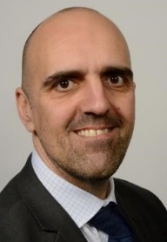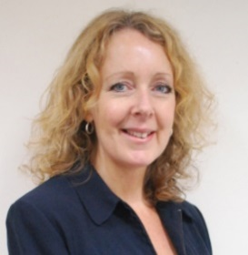

**Steve Dixon**

Chief Accountable Officer Salford CCG

**Charlotte Ramsden OBE**

Strategic Director, People

Salford City Council

Executive Summary

Back to Contents

**2021-22 Highlights: a summary of key developments and challenges in the last 12 months**

Despite the continued challenges and pressures over the last year, we have continued to deliver several key transformation programmes in 2021 and made progress on others. A summary of these is outlined below:

* Salford Thrive in Education (mental health support team): first 12 months delivery
* Gaddum: scale up and roll out of enhanced bereavement support for young people
* Neuro Development pathway: continued development, capacity and pressures
* COVID impact, recovery & surge planning and review work continued. The CAMHS COVID Surge Plan first implemented in December 2020 remains in place to manage service capacity and demand and to prioritise resources on the front door / duty and assessment and risk support offer. Similar service re-modelling has also started in 42nd street and joint work established between both services to collaboratively manage demand and risk, ensuring that young people are directed to the best service to meet their needs.
* Salford PPIMH programme development, stakeholder engagement and Implementation work
* A Service Review of all 42nd street provision in Salford has been undertaken between service leads and commissioners and with involvement of wider stakeholders and has shaped proposals for a service re-organisation and increased capacity from April 2022.
* The Thrive Partnership has continued to meet virtually with more focused agendas and a review of priorities was undertaken with partners in December 2021 to inform work plans for 2022.
* Ongoing delivery of Thrive and Trauma Training programmes, and feedback through these along with a training needs survey is helping shape training plans for 2022.
* Ongoing: Thrive Network: regular email bulletins continue to be sent out on providing service updates, information and resources alongside the Thrive webpages being kept updated
* The Thrive online directory was expanded and re-launched in 2021, to include even more information of support for young people and professionals.
* Crisis Care Pathway work and improved support for young people who present in distress, including the develop of the Parachute team model to be tested in Salford and rolled out across GM

Introduction

Back to Contents

**COVID-19**

The pandemic has continued to place a significant pressure on services and staff and has certainly impacted on priorities and workplans. This is reflected in increased demand for services and greater acuity and complexity of need amongst young people who are referred to / access our services. The picture is the same across inpatient and community settings, across GM and within Salford, across NHS providers and VCSE providers alike. The pandemic has continued to have a significant and ongoing impact on our residents, and for many children and young people and families in Salford has caused tremendous disruption to everyone’s lives and has heightened distress and anxieties and resulted in increased mental health needs. This has been especially true for young people that have pre-existing mental health illnesses and/or additional needs or disabilities.

Last year we highlighted the additional challenges for some children and young people who may already experience greater difficulties or vulnerabilities including those who are BAME, LGBTQ+, or come from disadvantaged backgrounds and may not have access to the resources they need to access online support, engage effectively in home learning, or to participate in hobbies and interests / sports and leisure activities, and to keep in touch with friends and families. Over the last 12 months we have targeted extra support to those with greatest levels of need and to those who have been disproportionately impacted by COVID. We have invested extra to support these groups through Public Health England funding awarded to Salford. which we have channelled through our VCSE services to offer more help to young people aged 16-24, people from our Orthodox Jewish Community, expectant / new parents with children under two and to those who have been impacted by bereavement.

Whilst the overriding impact of the pandemic has been negative and the challenges for services unparalleled, we have continued to be amazed by how our services, staff, schools, communities, and families have managed to continue to support children. The updates in this report highlight the ongoing effort and response across the system in Salford to support and improve children’s young people’s emotional wellbeing and mental health.

**Salford Thrive Plan – what is it?**

The Salford Thrive Plan is what we call our children and young people’s mental health (CYPMH) Local Transformation Plan. As stated in the guidance, these plans should be a ‘transparent, organic living document, locally developed by partnerships that include the NHS, Local Authority Children’s Services, the voluntary and third sector, education and justice agencies and children, young people and their families/carers’.

The aim of the plan is to:

* + demonstrate progress to date, achieved over the course of the Five Year Forward View for Mental Health,
  + take into account Covid-19 impact, recovery and restoration plans and
  + set out local ambitions to further improve children and young people’s mental health, as set out in the NHS Long Term Plan.

Our plan provides a progress update against Salford’s priorities but is aligned with the wider GM Health and Social Care Partnership and children’s mental health programme (and the emerging GM Integrated Care System (ICS) / Board NHS Long Term Plan. This our report includes a blend of local, regional and National priorities for children’s mental health.

Readers are reminded that whilst we review/refresh our Thrive Plan annually, this builds on previous annual reports which started with Salford’s first ‘CAMHS Transformation Plan’ published in 2015. As always, this update therefore needs to be read with reference to earlier reports and particularly the Salford Thrive Plan update 2021. Last year the Salford Thrive Partnership agreed to continue to deliver on our existing Ambitions and not to adopt any new priorities for 2021-22 in recognition of the need to focus our efforts on maintaining access to services and supporting those who most need help. We acknowledged the following would have a significant influence on delivery and capacity in 2021-22:

**Summary of key challenges:**

* COVID 19 – lockdown restrictions, access and pathways, health and safety, shift to digital access/remote working, re-introduction of face-to-face services, CYP difficulties in engaging in services from home (privacy, other priorities/family issues, technology)
* Surge pressures, service planning and assurance, frequency of communication across the system to keep children’s workforce, parents/carers and young people informed of changes
* Impacts on waiting times and pace/scale of development in online/digital offer
* Staff, service and commissioning capacity to deliver on priorities, develop, implement and monitor new projects services. Staff shortages, vacancies, sickness and self-isolation
* Maintaining service staff wellbeing and motivation

Key Lines of enquiry (KLOES)

Back to Contents

**What are the KLOEs?**

This document sets out the national ‘key lines of enquiry’ or strategic priorities and example indicators to support the updating of CYPMH Local Transformation Plans. It has been developed following consultation with regional leads and other stakeholders.

In December 2020, Children and Young People’s Mental Health (CYPMH) Commissioners in Greater Manchester undertook a review of local transformation plans and audited these against the latest KLOEs, providing a summary assessment against the national and GM expectations. We ‘RAG’ rated each priority area and provided assurance and references of what is in place or in development locally to deliver on the high-level priorities. This information fed into a GM Children’s’ and Young People’s Mental Health Plan Report in 2021 (See section 4 below).

The 2021 KLOEs were:

1. Transparency and Governance
2. Understanding Local Need and Addressing Health Inequality
3. CYPMH Local Transformation plan or CYPMH & WB Strategic Plan –Ambitions
4. Workforce
5. Health and Justice
6. CYP Eating Disorders
7. Data - Access and Outcomes
8. Urgent & Emergency (Crisis) Mental Health Care for CYP
9. Early Intervention in Psychosis (EIP)
10. CYP Mental Health Services working with education settings (including Mental Health Support Teams)
11. CYPMH Digitally-Enabled Care Pathways

NHS England have not yet issued a new set of KLOES for 2022 and we are not sure when or if this will happen. With NHS focus on service delivery and pressures, many of the national monitoring and reporting requirements have been stood down or reduced over the past year. We will therefore consider these when or if they are issued and will assess whether there are any gaps or areas of concern in which we have not made adequate progress.

GM CYP Mental Health Plan: 2020-21 update

Back to Contents

The GM Health and Social Care Partnership programme team have co-ordinated a GM Children’s and Young People’s LTP Report in autumn 2021 which provides an overall picture of performance against national targets and progress against national priorities across the ten GM localities. Salford provided a 2-page appendix which summarised local priorities and progress. The GM report addressed the 2021 KLOES and included updates on the following

* GM Mental Health Strategy and data, including national access and waits targets and work being done to maintain, sustain and improve
* GM transformation work programme which includes: Mental Health in Education; Crisis Care Pathway; Learning Disabilities and Autism; SEND; GM i-Thrive work and the Thrive model; Youth Justice; Perinatal and Parent Infant Mental Health; Community Eating disorder services
* NHS CAMHS Workforce Strategy
* GM Partnership working, governance and oversight
* Children’s and young people’s voice and engagement
* GM Covid-19 response

Our Ambitions: 2021-22 Achievements

Back to Contents

Please see below a reminder of Salford’s Thrive ‘Ambitions’ and young peoples’ ‘we statements’ which provides the structure for our annual Thrive Plan update reports.

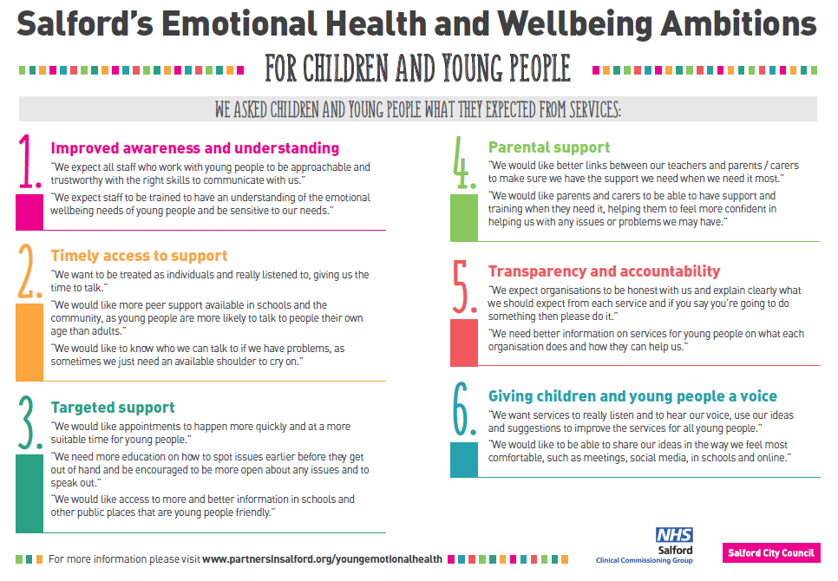

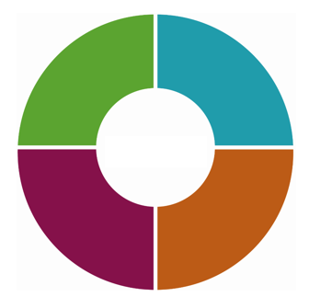

**AMBITION 1: Progress**

Back to Contents

**AMBITION 1: Improved awareness & understanding**

**Our Priorities last year were:**

* Access to appropriate support, supervision and network(s) to support children’s workforce to carry out their work safely and confidently
* Salford as a GM trailblazer site for roll out of Mental Health Support Teams in schools, building on CAMHS School Link model, EFS and other good practice (via national / GM roll out of Mental Health in Education programme)
* Continued delivery of mental health training and development to develop the children’s workforce skills and confidence (local programme and links to GM offer)

**Consultation and Support**

Over the past 18 months, the CAMHS duty function has provided enhanced support and a single point of contact for parents/families and professionals who are concerned about a child or are not sure about the best pathway or service to meet needs. The new Thrive in Education team (see below) has also been instrumental in providing improved access to consultation and support for the education sector and developing a peer support approach for education staff, working in collaboration with local authority teams/professionals, especially the Educational Psychology Service and early Help School-Co-ordinators. At a GM level, there is agreement across all CAMHS services to adopt the THRIVE model in CAMHS which includes offering consultation around risk support and advice and signposting.

One of most recent developments is an A&E Follow up pilot which started in September 2021 and is providing follow up advice and support for school mental health leads when a school refers a young person to A&E. This is both to ensure safe discharge and that appropriate support is offered to the young person and to mitigate any potentially inappropriate further attendances at A&E. The pilot is being jointly delivered and monitored by CAMHs I-Reach (part of our Thrive in Education team) and our Mental Health Liaison Service (provided by GMMH) based in Panda.

Salford is developing a GM Crisis Care Pilot called 'Parachute team' which will inlcudes both consultation, advice and support for professionals as well as early intervention, advocacy and wrap around support for young people and families/carers when they may be tipping into crisis or have presented in A&E. The aims of the pilot are to reduce A&E attendances and to provide early intervention to prevent cases escalating, by supporting professionals and young people in their settings where possible, or on step down from A&E back into the community. The pilot aims to go live in Spring / Summer 2022 in Salford and will inform the scoping and wider roll out of similar approaches across GM.

**Salford Thrive in Education (Mental Health Support Team)**

This arguably remains our biggest programme work and area of development, providing significant additional resources to support children and young people and schools across Salford, with a dedicated team of 18.5 WTE staff as part of blended delivery team including MFT CAMHS I-Reach, 42nd Street and Place 2 Be.

The TIE team are supported by Salford City Council’s Educational Psychology Service and Early Help Schools Co-ordinator’s. The wider team around the school approach involves a host of other teams and services that work with and support our schools.

As well as delivering 1-2-1 mental health interventions for young people in education, the team offer training, advice and consultation, support with onward referral to specialist services, links to voluntary and community services, and support with whole school approaches and school development plans.

In 2021 we have also been working up plans for pilots to test peer support/mentoring training for young people to be peer supporters and emotional health champions. We have also started delivering pilots to test physical activity interventions as alternative models of support for improving children’s wellbeing through engagement in sports and/or physical activities.

In the first year of delivery from October 2020, 465 individual children and young people were supported by the Salford TIE team. The activity and caseloads were higher than in other areas partly because the Salford team hit the ground running quicker with an existing albeit small CAMHS Link / I-Reach team which already had a small caseload. A summary of the activity and outcomes for 2020-21 is included below. For more information about the first year of delivery, please see our TIE MHST Year One Report (September 2020 – August 2022): [Thrive in Education | Partners in Salford](https://eur02.safelinks.protection.outlook.com/?url=https%3A%2F%2Fwww.partnersinsalford.org%2Fsalford-0-25-advisory-board%2Fsalford-thrive-ehwb%2Fthrive-in-education%2F&data=05%7C01%7Cemily.edwards%40salford.gov.uk%7Cd41eb4a8b3ca40f5fa2908da28f5ecf3%7C68c00060d80e40a5b83f3b8a5bc570b5%7C0%7C0%7C637867333940289173%7CUnknown%7CTWFpbGZsb3d8eyJWIjoiMC4wLjAwMDAiLCJQIjoiV2luMzIiLCJBTiI6Ik1haWwiLCJXVCI6Mn0%3D%7C3000%7C%7C%7C&sdata=Rynw4FxlWbUHJx6GMz%2BwWV3VtJ0Mo%2F5wEy%2Fg5uTUDFI%3D&reserved=0).

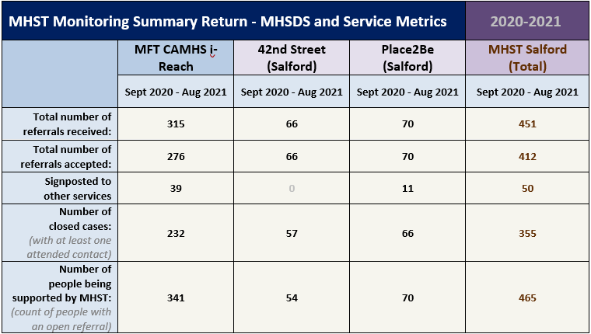

**The National Link Programme (new): working with our Orthodox Jewish Community schools**

In 2020 we put in an expression of interest to be part of wave 3 of the Department of Education funded ‘Link Programme’, delivered by the Anna Freud Centre, which provides a free facilitation and tailored support for CCGs, local authorities, education settings and mental health and other services to work together to improve knowledge and understanding and to develop and improve links and support joint working. The focus is on developing good relationships between schools and mental health services and thereby improving access to mental health support for young people in education.

The Link Programme uses the CASCADE framework which is a pragmatic tool developed for use with stakeholders working with children and young people (CYP) to identify levels of joint working across seven key domains. It is intended to help partners find ways of working together more effectively to better support CYP’s mental health.

In Salford we requested to specifically focus on working with our Orthodox Jewish Community (OJC) schools with the aim of improving the connections between school staff, mental health service and local authority early help and education leads. This was a ‘first’ for the Anna Freud Centre and they were extremely flexible and supportive, putting a lot of extra work in alongside CCG, Council and Mental Health leads to engage our OJC schools and to tailor and prepare for the programme. During COVID the Link Programme has been delivered via Zoom, and whilst our first ‘strategic consultation’ session was held virtually, we arranged a face-to-face workshop with schools and services which was held in Salford. This helped hugely in overcoming potential barriers, engaging schools, and building trusted relationships.

The Anna Freud team are currently in the process of writing up the Salford Link Programme as a case study and example of best practice to share nationally.

The Goals we have agreed through the programme, which we will take forward in 2022-23 were:

1. To re-connect / re-engage with OJC schools via EFS (supported by the Educational Psychology Service, Early Help School Co-ordinators and Compass)
2. Beginning with a small number of schools and Salford health service representatives to better understand the needs/wants within the community and build communication and trust.
3. To commission a ‘cultural exchange’ or local cultural awareness training offer for local authority and CCG services and professionals who have a role in supporting schools/improving children's mental health to ensure improved understanding of cultural needs within the community.

We decided that Goal 3 was our priority and would lay the foundations for future joint work and work is already underway to consult and engage across the community and with schools about what is important to include in the scope for this training. Schools are also really keen to understand more about mental health services, thresholds of need (and how these may be different for OJC families), and to access consultation and advice to support their work with young people. We have agreed to work together to establish a small number of Thrive in Education (MHST) pilots in OJC schools from September 2022, with each of our three providers working in at least one school each in the first year. We are also seeking to shape a GM approach across the local authority boundaries of Salford, Manchester and Bury to ensure a joined-up approach to support the unique needs of the community, no matter where a young person lives or goes to school or where they are registered with a GP. This approach is a priority need for the community.

**Training and Workforce Development**

The Salford Thrive training programme for 2021-22 focused on the continued delivery of the Youth Mental Health First Aid (MHFA) training both for schools and the wider workforce, and additional suicide awareness briefings and training sessions.

**Youth MHFA:** In response to depleted number of Salford MHFA trainers due to instructors moving to new roles, the Thrive training programme has commissioned train the trainer (TTT) training from MHFA England for a new cohort of trainers. By March 2022 there will be a cohort of mental health first aid trainers ready to deliver across Salford City Council and Salford CAMHS teams.

**Suicide Awareness:** Papyrus were commissioned to deliver a series of briefings and short training sessions. The Applied Suicide Intervention Skills Training (ASIST) training was postponed in 2021 due to pandemic restrictions but is re-scheduled for delivery in 2022. Asist is a two-day interactive workshop in suicide first aid and more. ASIST teaches participants to recognise when someone may have thoughts of suicide and work with them to create a plan that will support their immediate safety.

**Suicide Prevention Training:** Building on the success of Suicide Prevention training in Greater Manchester, Salford commissioned eight additional online training sessions for suicide prevention. Each session supported 15 participants, delivering the programme to a total of 120 participants across the system. To ensure that the training was as effective as possible, places were targeted to frontline services including: Advice Services, Bereavement Support (e.g. cemeteries), Gateway staff, VCSE Ethnic Minority organisations, diverse community leaders and care staff. Feedback from the sessions has been extremely positive. Further to the specific training sessions, 20 minute ‘Save a Life’ training is available free of charge across the community to support an increase in skills and confidence when supporting conversations relating to suicide. <https://shiningalightonsuicide.org.uk/learn-to-save-a-life/>

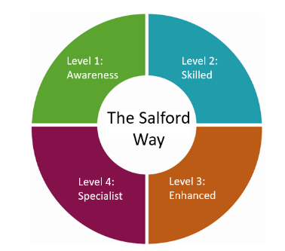

**The Salford Way:** Across Salford the recognition of Adverse Childhood Experiences and development of a Trauma Informed response to adversity are key to reducing poor outcomes for children and families. The Salford Way strategy and aligned work programme will support the workforce in the early identification and prevention of additional traumas in a child’s life and provide a universal language to aid practitioners to recognise their own and other’s needs.

Training has played a key role in the work, supporting staff to have the skills, understanding and confidence to work in a trauma informed way. The Salford Way training offer has been developed to align to the Thrive model.

Trauma informed training was widely delivered across 2021 and early 2022. Enhanced trauma training was delivered by Zoe Lodrick and Steve Brock, specialists in the field of trauma informed practice and Norma Howes delivered a range of training courses to support the workforce in trauma informed practice.  More than 1588 people have participated in training to date from across the Salford education, health, children’s services, housing, welfare rights and Salford VSCE sector workforce in 2021-22. More work is ongoing to develop a trauma training schedule for Salford with more tailored approaches, including practical tips for implementation. This will include staff across the system.

**Service briefings and engagement work**

We continue to facilitate online and face to face briefing sessions to raise awareness and promote new services, supporting anyone working or volunteering within the city.

[**Kooth**](https://www.kooth.com/)**:** launched in Salford in April 2020, provides free online counselling for young people aged 11- 18 along with a wide range of resources including chat forums, self-help resources and crisis information. Launching during the pandemic was a real challenge and take up of the service has been lower than we/GM expected, despite ongoing marketing and promoting through Salford Thrive Partnership and the Thrive Network, and via School and GP newsletters and through promotion to children’s services. From September 2021, Kooth were able to present to Salford school assemblies, and engage a range of services to promote their offer including pharmacies as well as GPs, directly to children’s services teams, mental health services and social media. Kooth has worked well in partnership with Thrive partners ensuring the offer compliments other services and that there is great take up of this early help provision to help prevent issues escalating and the need for more specialist services. In 2022 the service aims to be more visible and part of signposting across all Salford services and communities

**Children’s Eating Disorders:** there were plans for MFT to deliver targeted briefings for schools in 2021 but this has been pushed back due to service pressures and is now scheduled in March 2022. This will be open to the wider children’s workforce.

**Wellbeing for Education Return**

The video clips and resources developed to support the 20/21 wellbeing for education Return webinars and themed support sessions remain available on the Emotionally Friendly Settings (EFS) website: [Wellbeing Return to Education (WER) | Emotionally Friendly Settings](https://eur02.safelinks.protection.outlook.com/?url=https%3A%2F%2Fwww.emotionallyfriendly.co.uk%2Fresources%2Fwellbeing-return-to-education-wer%2F&data=04%7C01%7Channah.cartmell%40salford.gov.uk%7Cdadfef72c6c449c2e72608d9e0443b3d%7C68c00060d80e40a5b83f3b8a5bc570b5%7C0%7C0%7C637787405912410078%7CUnknown%7CTWFpbGZsb3d8eyJWIjoiMC4wLjAwMDAiLCJQIjoiV2luMzIiLCJBTiI6Ik1haWwiLCJXVCI6Mn0%3D%7C3000&sdata=E7Z%2Ftjy0lCLqqTC9iyldHbrQ7lP1mpSK1DwchcNK1EE%3D&reserved=0), covering topics such as staff wellbeing, resilience, supporting loss and bereavement and trauma informed approaches. The focus for the 21/22 academic year is to continue supporting Salford’s Emotionally Based School Avoidance (EBSA) Pathway, including a project to address very enhanced EBSA in conjunction with The Canterbury Centre and the Elective Home Education Co-ordinator,  alongside the development and delivery of a Right to Play training package for primary, secondary and special schools, recognising and promoting the importance of prioritising play and social development to support children and young people’s recovery and development.

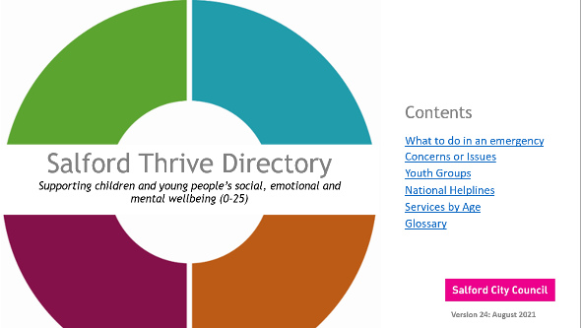**Thrive communications and resources**

Communications and engagement have continued to be critical over the past year in supporting the Salford workforce, parents, families and young people with accurate and timely information about services, training, COVID support and resources to help those working with children and young people.

The [Thrive Directory](https://www.partnersinsalford.org/media/keyfo40o/thrive-directory-aug-2021.pdf) has continued to grow its reach and in 2021 doubled its views compared to the previous year. Between April and December 2021, the page hosting the directory had 1717 views of which 1431 were unique users, spending on average 2.34 minutes on the page.

The page hosting the website has been upgraded in November 2021 and the Directory had a refresh and relaunch in August 2021.

The directory is also accessible via the Salford Local Offer for parents and carers, with the [Youth Zone](https://www.salford.gov.uk/children-and-families/youth-zone/) webpages providing information on emotional health and wellbeing, including access to the online directory.

[Find my future](https://www.salford.gov.uk/jobs-skills-and-work/find-my-future/) pages hosted by Salford City Council website also provide advice and links to the Directory. Maintaining and developing the Salford Thrive webpages will remain a priority for us in 2022.

**AMBITION 2: Progress**



Back to Contents

**AMBITION 2: Timely access to effective child centred EHWB support**

**Our Priorities last year were:**

* EFS implementation in new settings – early years and post 16 education and training
* Finalise and implement new transitions policy and guidance for young people with complex needs, and to support improved mental health transitions
* Delivery of quality eating disorder pathways for young people, with non-interruption of care at age 18 and / or earlier access to adult services if and when needed
* More work on delivering an improved health (including mental health) offer for care leavers, and improved transitions between children’s and adult services.

**Emotionally Friendly Settings (EFS)**

* **EFS: Early Years (EY)**

The Educational Psychology Service (EPS) have been offering Early Years (EY) EFS to the non-school settings (the PVI nurseries, LA nurseries) in Salford through our Starting Life Well project time, in both the last academic year and this. We launched EY EFS at the Wellbeing Day in March 2021 and invited settings to express interest.

To date, 13 settings have expressed interest and have been contacted by Educational Psychologists (EPs) to start the process; not all have due to changes of circumstances (e.g., COVID, OfSTED) but we are following this up. Others have had their Whole School Training (WST) or have planned it, some have had an Action Planning Meeting (APM), some are at the stage of doing the audits. We are holding another EY wellbeing day which is a bit like a mini-EFS conference for Early Years, again provided through our SLW project time.

We are beginning to pilot EY EFS in Tameside and it has also been offered to Bury.

* **EFS: School Age**

EFS WST and APMs have been recorded in 23 Salford school settings in 2021 and 2022 to date; fourteen of these are Thrive in Education settings. In this period, eight initial WST sessions have been delivered and eleven WST refresher sessions have been delivered; six initial APMs have been delivered and six review APMs have been delivered.

There are currently thirteen schools that have a Bronze accreditation and one school that has a silver accreditation. One of these schools is out of borough. Nineteen schools have expressed an interest in pursuing accreditation, of which two will be assessed at the Spring accreditation panel and five have requested to be assessed at the Summer panel.

* **EFS: Post 16**

We are working with the design team for the manuals by arranging photography and deciding who will complete the design of the manual before it can be printed. Worsley College, our pilot setting, are reviewing their APM and WST.

We have explored the new accreditation criteria and the process with Worsley College and gathered feedback on this process and are making changes to certain criteria so that it is suitable for college settings. Worsley College would like to go for their accreditation at some point during 2022.

All campuses at Salford City College are planning to implement EFS separately, so we will have approximately another 4 settings involved with EFS by the end of the year.

All 5 colleges have accessed training around different areas of mental health and emotional wellbeing this term; these have covered: two sessions on anxiety, self-harm and managing difficult emotions. We will also complete the attachment and trauma training for them in the summer term.

**EFS Conference**

The 2021 conference was held virtually and 90 people attended. The theme was *Building Emotionally Communities Where Everyone Can Thrive*. This year the conference will be delivered virtually on 24th May 2022 and will be a half day event; the date has been circulated to schools. This will be the 7th annual conference and the theme is likely to be linked to reconnecting emotionally friendly school communities and social justice. Content will include input on the accreditation process, showcasing examples of best practice in Salford and other Local Authorities, play, building mentally healthy foundations and post traumatic growth. This will be offered as a free event.

**Transitions Policy and Working Group**

The Salford Multi Agency Transition Policy has now been approved via Council and CCG governance and individual services. The Transitions working group has continued to meet to co-ordinate an improved approach to transitions for young people into adult services when needed and to ensure continuity of support for those with complex needs, disabilities, SEND and mental health diagnoses or ongoing support needs. Transitions panels are co-ordinated and supported by the Complex Needs Transitions team. From a mental health perspective, both children’s and adult service leads, and commissioners have worked together to review how the new policy and guidance is working in practice and to agree areas for development, including plans for a multi-agency refresher in 2022 to ensure that any new staff are full understanding of their responsibilities in supporting good transitions planning which meets NICE guidance. An outcomes framework and monitoring process is in development which will provide the assurance that everyone is working towards the policy and guidance.

**‘So Much More’**

A project named ‘So Much More’ has commenced following the management of a challenging and complex case where a Cared for Child had an extended mental health admission to an external acute trust. The aim of the project is to strengthen partnership arrangements for managing our most challenging cases, improving the way services prepare young people for adulthood through earlier recognition and intervention. Lessons learnt have identified barriers in this area of practice due to language and practice around the term ‘transitions’. The project will aim to address these barriers and improve continuation of care from children to adult services with collaborative assessments and increasing awareness of statutory responsibilities for services and commissioning. This unique project demonstrates our commitment to caring for children in Salford who deserve ‘So Much More’.

**Children’s Eating Disorder Service (CEDS)**

Salford’s CEDS staffing establishment is 5.1 WTE. One 1.0 WTE B7 Senior ED practitioner is currently completing their ACP Training, due to finish in September 2022. MFT have successfully recruited a Community Support Worker who will be primarily supporting our ARFID Service. ARFID is a relatively new term and stands for avoidant/restrictive food intake disorder. It has also previously been known as Selective Eating Disorder. MFT have been involved in a National pilot for ARFID and is now funded by Salford and Manchester CCGs to develop support for this locally.

ARFID is characterised by a pattern of eating that avoids certain foods or food groups entirely and/or is restricted in quantity (eating small amounts). Avoidant and restrictive eating cannot be due to lack of available food, or cultural norms (e.g. someone who is fasting or chooses not to eat certain foods for religious or cultural reasons alone).

ARFID is different to other restrictive eating disorders in that:

* ARFID isn't affected by a person’s beliefs about the size and shape of their body.
* Someone with ARFID doesn't restrict their food intake for the specific purpose of losing weight.
* ARFID doesn’t feature some of the other behaviours that can be associated with anorexia, bulimia, or OSFED, such as over-exercising.

CEDS continues to meet national targets and ensure that 100% of Salford’s young people are offered urgent and routine appointments within the standards of 1 week and 4 weeks respectively. Despite this, it should be noted that demand for routine support has increased considerably over the past year, with a 30% rise in referrals from 44 received in 2020-21 to 63 in 2021-22. This will need close monitoring to ensure the team has capacity to meet needs across both Salford and the wider MFT footprint (i.e. Salford, Manchester and Trafford). See Section 7 for more information on performance against national targets.

A key challenge in 2022 was the migration of Trafford from Pennine to MFT CEDS, inheriting 37 open cases on the 1st April 2021 when most of the staffing who would hold a caseload were not in post until later that month. This required clinical intervention to be provided to families by the existing staff, in addition to their existing Manchester caseload. In addition, there has been a significant rise in demand for CEDS particularly Manchester and Trafford, and MFT has altered commissioners to potential impacts on the Salford service if this rising demand continues. We continue to monitor this situation. A CEDS Case study is included in Appendix C.

**Improved support for Care Leavers**

* **Pure Insights**

Pure Insight were jointly commissioned by Salford City Council and CCG in August 2020 to provide a range of targeted emotional support for young people aged 16-25+who have left or are about to leave statutory care.

Since August 2020 the service has successfully mentored 36 young people; 38 young people have received interventions from a psychological wellbeing worker and 32 young people received trauma counselling. 102 young people have received some form of advice of help from the service.

Multiple additional outcomes were also reported including reduced substance misuse, secured tenancies and young people supported into education, employment and training or volunteering.

This year the service has also opened a drop in café in Little Hulton for Salford Care Leavers and a Care Leaver is exploring options to become a mentor on the scheme for other young people.

* **Steps Ahead**

Steps Ahead is a Salford CCG Innovation Funded project that started in 2021 which sits within the Next Step leaving care team. The call too innovation came from the need to look at the unmet need around young people who are care leavers and over 18 accessing primary care services. The project consists of an outreach GP; 42nd Street support worker and a link worker. The 6-month report has highlighted green shoots outcomes for young people and anecdotally there has been a drop in numbers of young people presenting at A&E who are known to Next Step. Funding has been extended for a further year to fully evaluate the project to build a business case for recurrent funding.

**Bereavement & Palliative Care Counselling**

In 2020 additional funding was awarded to Gaddum to increase the offer for young people for bereavement counselling within the Bereavement and Child Palliative Care Counselling Service.

Over a 15-month period since funding was increased 35 children & young people have accessed therapy with 52 families being supported. On top of these sessions the service have attended 67 multidisciplinary engagement sessions; delivered 103 psycho education sessions and produced a court report.

There is scope in 2022 to widen the scope and improve the quality of the Palliative Care Counselling Service. There is a proposed name change to Complex Care Therapy Service to align the service further with the community nursing teams where all referrals flow from. The service is looking at changing the model of delivery to create a holistic, targeted offer which encompasses the whole family where a need is identified.

**AMBITION 3: Progress**



Back to Contents

**AMBITION 3: Targeted support for the most vulnerable, and improved crisis care**

**Our Priorities were:**

* Contribute to the development of a new Inclusion strategy, and ensure that services support the most vulnerable including LGBTQ+, BME, LAC and young carers,
* Implementation of a new needs-led integrated neuro development pathway
* Roll-out of ICRS across Salford’s Early Help Hubs
* Implement Peri-natal and infant mental health programme in Salford (including Home-start (see Ambition 4)
* Continued development of our Youth Justice offer (locally and GM programme)
* Develop ‘risk support’ guidance for practitioners to support young people in distress and / or in crisis, experiencing self-harm and suicidal ideation

**Education Inclusion Strategy**

Multi-agency work has continued on the Strategy with many elements now in place, and others being more fully developed in their own right. The Team Around the School strand has now become a significant and separate workstream under Early Help, led on by an Early Help Manager with the support of the Innovation Unit. This is a 12-month development and implementation project. Under Strand 2, reviews of systems and processes taken place. There is now increased challenge around suspensions, and increased capacity to support and challenge around attendance. We have supported roll of out of SEND Graduated Response. Significantly, to improve the strategic reach and provide accountability for the work, we have created a Vulnerable Learners Partnership Board set up, chaired by AD Education, Work & Skills. The Trauma responsive work in Strand 3 has continued, linking very closely with the Thrive work. Trauma responsive training has been rolled out across the LA and will be rolled out in schools shortly. A trauma responsive relationship policy has been written and being piloted in several schools. There is now a Supervision programme in place for Designated Safeguarding Leads in schools.

**Support for LGBTQ+ young people in Salford**

The Salford LGBTQ+ working group was paused for most of 2021 due to COVID pressures on services. In addition, the chair of the working group moved to another area, which has impacted on momentum. The Group held a restart meeting in December 2021.

The LGBTQ+ Inclusivity Resource Handbook designed in 2020 has been developed by 42nd Street and Salford Youth Service is still available for all educational settings and services. The handbook has been designed to provide productive and accessible tools for LGBTQ+ inclusion and aims to bridge any gaps in knowledge and provide an insightful and productive resource for improving LGBTQ+ inclusion across the city.

Salford Youth Service continues to deliver the LGBTQ+ Youth Groups. There are currently 3 youth groups in North, South and West localities with a 4th coming on stream in the East locality by March. The Youth Service has also employed a young apprentice from KICKSTART who will be managing the East Locality group. Every 3rd Sunday of the month is the T & Toast Trans only space for young people and running parallel to this is the T & Toast parents’ group.

Training is currently in development regarding gender diverse individuals; this is training is in the testing phase and will be rolled out throughout the year to all education settings and professionals.

**Salford’s Neuro-Developmental Pathway**

The Salford Neurodevelopmental Pathway was launched in January 2021 as a needs-led assessment process for children and young people who may have neurodevelopmental conditions including Attention Deficit Disorder (ADHD) and Autism Spectrum Conditions (ASD). The aim of the pathway was to provide wrap around support where needed for families and children and to reduce the need for multiple referrals to a wide range of professionals and to streamline the process for identification of the right support at the right time by the right person.

As the pathway has developed, the Neurodevelopmental Steering group attended by Community Paediatrics, CAMHs, Early Help, Children’s services, Commissioners and the Neurodevelopmental Coordinator have dedicated significant time to developing, refining and testing the pathway.

In December 2021 the Neurodevelopmental Steering Group identified a need to pause accepting referrals on the Salford Neurodevelopmental Pathway for 8 weeks to enable a review of cases and refinement of the pathway. This was due to the high levels of demand and significant waiting lists at different levels of the pathway. The pause has since been extended a further 4 weeks till 25th April 2022 to address key issues such as implementation of a new online referral form, ongoing triage of referrals from the backlog, website development, further work with services and provision of workshops/drop-ins. A complaints process has also been established, triage and panel meetings have been restructured and feedback and comments have been gathered through parent and professional surveys. Further engagement is planned with parents and professionals and a business case is being developed to outline the requirements for further resource.

There are significant waiting lists in services delivering neurodevelopmental assessment and support – this is an ongoing challenge being addressed at service level but it currently means long waiting times for parents families. The demand for neurodevelopmental assessments, diagnosis and support is significant in Salford and work needs to be done to develop a collective system response to this challenge as it is a key responsibility for services. Support must be available for children, parents and families across the system and further training, engagement and commitment is required to enable this.

**Riding The Rapids**

GM Health and Social Care Partnership commissioned training for staff in Riding the Rapids: A Parenting Intervention for Families Supporting Children and Young people with Learning Disabilities and/or Autism. The aim is to train 100 practitioners across GM by the end of 2021-22. Facilitators are trained in groups of 10 from the same geographical area so they can form a community of practice.

Riding the Rapids (RTR) is a ten-week group intervention aimed at helping parents/carers of children with additional needs to positively understand and manage their child’s behaviour, improving quality of life and equipping families with skills to take on their journey with them. Designed for parents of children with learning disabilities and/or autism the group materials can be adapted to support parents of children in specialist or in mainstream provision. The course is divided into different modules including:

* understanding the function of behaviour that challenges
* making environmental changes to support positive behaviour
* developing strategies to promote positive behaviour based on this understanding
* promoting positive attachments through better communication and play
* supporting parental self-care and promoting parental coping and wellbeing

RTR fits well with our plans to develop and roll-out an improved support offer for parents/carers and families in Salford. Salford practitioners undertook their training between 14th- 16th June 2021. It fits to the ‘getting help’ quadrant of Thrive model of care & provides a first step offer of support for parents following service post diagnosis workshops, though can also be offer pre diagnosis if the parents/carers are not in mixed groups. It is anticipated that this training will make a real difference to the ambition for a rolling programme of support for parents in Salford as part of the neuro development pathway. However, the plan for roll out of the programme has not yet been agreed due to current service capacity and pressures and will remain under review by partners thought the NDP steering group.

**Salford’s Integrated Community Responsive Service (ICRS)**

ICRS is a multi-agency service with mental health support delivered by 42nd street, welfare rights and debt advice support for the family provided by Mind in Salford, E-therapy delivered by Self Help Services and consultation provided though CAMHS. Referrals and mental health support are integrated with Salford’s Early Help and Family Hubs. The service provides targeted early help support for young people presenting in mental health distress and at increased risk of crisis presentation. The aim is to identify young people in distress and to offer early intervention to prevent the issues from escalating further.

ICRS was approved for recurrent funding in 2020 and in the last 12 months links have been made with R29 (Salford’s no wrong door approach) to agree plans for a targeted offer for young people who are ‘edge of care’. Initial links have also been established with the All-Age Mental Health Liaison Service in A&E to consider how ICRS could be offered as an additional option for discharge from A&E, however this hasn’t been progressed in light of the parachute team development (see below) and the re-commissioning of Safezones by GM, both of which will provide new/improved options following A&E discharge. There have been ongoing discussions about the desire to roll out ICR in the other two Early Help locality teams OR moving existing resources to other localities where ICRS links are already well established. A business case has been made for additional ICRS capacity to enable expansion.

Early Help teams continue to feed back that ICR workers support with case discussions is invaluable, supporting practitioners with information, advice and strategies to support young people on Early Help caseloads, particularly around issues such as anxiety, low mood and school avoidance.

The impact of COVID has meant more young people are presenting with higher levels of need and increased complexity. This has meant that the ICR service has been required to provide increased support with case management and safeguarding. ICR workers have continued to operate throughout the pandemic, with remote support (video, telephone, online) and some face to face over the period.

**Parachute Team Salford – a GM pilot**

In 2021, the ICRS model has been used to inform the development of a GM ‘Parachute Team’ approach which will be piloted in Salford and aims to add value to the GM Crisis Care Pathways by supporting those distressed young people who do not have a mental health diagnosis and do not meet thresholds for Tier 4 admission but continue to present with urgent needs for support with de-escalation, stabilisation and advocacy to ensure they are supported to deal with the many stressors that are the route of their distress.

Reviewing case studies has been a key element to the development of the Parachute model. The types of cases that this model will support may benefit from earlier intervention (e.g. pre-crisis care intervention) or might need ongoing / additional support following crisis care support e.g. by the Rapid Response Team or All Age Mental Health Liaison team. Parachute aims to ‘add value’ to the existing GM/local offer and to address the gaps in this, and by co-locating with social care teams and supporting the multi-agency ‘professionals’ meetings we hope to achieve improved co-ordination of care planning for young people who present in distress. 42nd Street is working closely with GM and Salford crisis care partners, with social care professionals, and with commissioners across the wider GM footprint to help shape the Parachute pilot model. Parachute aims to start in shadow form in Spring 2022 and will run for 6 months to test and learn what works well to refine the model before wider roll out. The safeguarding impact of mental, emotional health and wellbeing should be reduced by implementation of this trauma informed model.

**Implementing a Perinatal and Parent Infant Mental Health (PPIMH) service**

A great deal of work has been undertaken during the last 12 months to develop this work programme. A PPIMH Implementation group was established to develop a joint mobilisation plan with input across CCG and Council, Public Health, Children’s and Adults commissioning, and Early Help leads. The initial Salford business case approved in December 2020 was reviewed with partners and following consultation with the GM clinical lead it was determined that the CAMHS ‘PIMH’ service element would not meet the GM specification requirements or level of need in Salford, so was refreshed and resubmitted to CCG. The revised CAMHS PIMH staffing model was approved in July 2021 and will provide the following core PIMH team:

* 1 x 0.8 WTE 8B Child Psychologist/psychotherapist, who would have the skills and experience to have strategic and organisational influence as well as shaping a quality clinical service. This Salford PIMH lead will provide strong strategic leadership in PIMH for the service within GM utilising already established links with key partners to contribute to the further development of a clear and integrated parent-infant pathway. This may be an experienced child psychotherapist who could further enhance the knowledge, skill mix and expertise across MFT and offer leadership, consultation and clinical input. Parent Infant Psychotherapy is developing a strong evidence base in PIMH and most PIMH services around the country have a psychotherapy role as core within their skill mix.
* In line with the population need and the likely demand, an additional 1 WTE B7 PIMH Practitioner who may have a background as either a specialist PIMH health visitor or Child Clinical Psychologist, will offer adequate assessment and intervention to address PIMH need.
* 1 WTE B4 Information Officer/Admin support (instead of 0.5 WTE). To support the data flow to meet the National and GM data reporting and local information and performance monitoring.

Our vision is for an Integrated PPIMH service offer for parents pre and postnatally and to work with families and infants up to age 5, though focusing initially on 0-2. Many elements are already in place or in development including Peri-natal IAPT, health visiting and midwifery, Early Help and Homestart. A GP PIMH lead has been identified and the CCG GP Lead for children and young people have been engaged to support this work and a successful stakeholder engagement event was held in October 2021. A proposal for continued funding of the Salford Dad Matters service was approved in February 2022 and work is now underway to set up a ‘design group’ with operational and service leads working together to work up the service and pathway model, to identify venues for co-located delivery (based on a hub and spoke model) and building on plans for a network of Early Help Family Hubs in each neighbourhood. The CAMHS PIMH team roles were successfully recruited by end of March 2022 and are due to start in post from May.

**Youth Justice Service (YJS) targeted CAMHS support**

Salford continues to benefit from a targeted YJS CAMS worker, who is co-located with the YJS team and provides both 1-2-1 assessment and support and consultation and advice for professionals, input to care plans, pre-sentence reports, staff training and supervision, and via complex case panels. Consultation and advice around sexually harmful behaviour, remains a key area of staff support, mainly for children with learning disabilities, as well as advice and support around young people who self-harm and have suicide ideation. However, over the past year, there has been a focus on embedding learning around trauma and resilience into YJS work following the extensive training programme provided in Salford this year. Despite COVID, the CAMHS YJS worker has continued to support young people and staff remotely via digital technologies and provided support in community settings for those who have needed face to face support and when possible within COVID safety rules, including supporting joint home visits for young people identified at risk. Group work also resumed over the summer.

The YJS CAMHS worker also continues to support young people to access other specialist services and assessments such as ADHD assessments and psychiatry appointments, which in turn support young people to better understand their own behaviours/responses to aspects with their day to life, both at home and in other settings such as education. Between April and September 2021, the CAMHS YJS worker provided 113 1-2-1 appointments and supported 35 staff consultations. 16 new referrals were also accepted.

In the last year, a number of complex young people have presented where their underlying mental health difficulties has been a significant factor in their offending. Consultations with the youth justice staff and linked professionals have assisted in the understanding of a young person’s presenting difficulties and to formulate appropriate support options with the aim to reduce further offending.

The YJS worker has also developed a productive working partnership with the Psychologist based with the Route 29 to support the young people who are often open to both services, to reduce duplication and to share expertise. To support the formulation and planning of appropriate mental health support for these young people, the YJS worker and R29 Psychologist now meet weekly to discuss cases and offer joint assessment /consultations.

**Improving risk support and crisis care pathways: a strengths based approach for supporting young people in distress**

Following the initial focused session to explore crisis care and risk support held in 2020, a Strengths Based working group was established to improve awareness and understanding, and to support joint working and improved support for Salford young people who present in distress and/or crisis, in various services across the system.

The working group, chaired by Debbie Blackburn, Assistant Director of Public Health Nursing and Wellbeing, now regularly brings together key professionals across the GM Crisis Care pathway, and Salford system, including GMAIC, Tier 4, Rapid Response Team, All Age Mental Health Liaison Team (AAMHLT), A&E, safeguarding and clinical leads, CAMHS, Social Care, along with local and GM commissioners.

Over the past 12 months this has helped all services and professionals to foster improved connections and gain a better understand of the crisis care pathways and protocols. GM has developed a high-level crisis care flow diagram, which in underpinned by a pathway overview for each key service. Individual cases have been reviewed to support joint action plans and multi-agency working. Salford’s multi-agency panels and governance arrangements have been mapped and reviewed to inform how these can be simplified and improved. A GM Escalation Policy has been drafted and GM guidance around crisis care pathways.

This work has provided a foundation for the Parachute teamwork described above and was also the driver for workforce development plans and reciprocal work shadowing/placements across CAMHS and Social Care teams. A review has been undertaken of the 7 day follow up and discharge protocols from A&E following young people receiving a mental health assessment, which has supported increased collaboration between CAMHS Duty and AAMHL team, and options for improving the discharge pathways from A&E. Monitoring of school referring young people to A&E is helping to provide a targeted follow up via the Thrive in Education team & CAMHS to understand the reasons for schools taking this approach and to reduce unnecessary referrals to A&E through improved access to consultation and advice from CAMHS/TIE teams instead. The range of workstreams underway is beginning to deliver greater collaborative working and a there is a genuine commitment from all partners to improving the experience and outcomes for young people who experience distress and crisis.

**Domestic Abuse and BOND programme (New)**

A new Lead Provider model has been procured through a competitive tender process to deliver integrated Domestic Abuse services in Salford. A new partnership of four charities has been selected to provide Domestic Abuse services in Salford from April 2022. Salford Foundation, Pankhurst Trust (Manchester Women’s Aid), TLC: Talk, Listen, Change and Trafford Domestic Abuse Service (TDAS) have come together to create the new “Safe in Salford” Domestic Abuse service.

The new service is jointly funded by Salford City Council, Salford NHS Clinical Commissioning Group (CCG) and Greater Manchester Police. The five-year contract has been awarded to Salford Foundation, who will lead the new service in a Lead Provider model. Under this new way of working, the 30-year-old social inclusion charity will sub-contract to Partnership providers and co-ordinate a wide range of services to support victims and survivors, children and young people, and perpetrators who want to change their behaviour.

Previously, these services have been delivered separately. The new model of delivery will involve a ‘one front door’ approach, so that support and challenge is co-ordinated seamlessly. This will enable a significant shift in how domestic abuse is tackled in the city. The partnership will provide a range of complementary services including individual support, group activities, safety planning and training for professionals from a range of venues across Salford.

The “Safe in Salford” partnership is being designed to be flexible and accessible, offering person-centred, trauma informed safety and support. The aim is to achieve this by working collaboratively with partners in the public, private and voluntary sectors.

The new service will go live from 1st April 2022 and significant work has been completed and is ongoing to establish clear referral pathways, governance and monitoring, communications and service models.



**AMBITION 4: Progress**

Back to Contents

**AMBITION 4: Parental support and programmes for those who need it**

**care**

**Our Priorities last year were:**

* Contribute to the development of a Salford Parenting Strategy, in partnership with parents in Salford (to include parent resilience, physical / mental and social health)
* Maintain / develop our neighbourhood parent peer support groups
* Continued co-production of the adult ‘Living Well’ model, to pilot in one area of Salford from 2020
* Continuation of Home-start baby Bond (as part of new PIMH – see Ambition 3) and implement new support for dads though ‘Dads Matter’

**Developing a Salford Parenting Strategy, and parenting support**

We have developed a parenting strategy for Salford which includes evidence based parenting interventions available across the thresholds of need. Central to this is the Solihull Approach - our population level offer. The Solihull programmes enable families to access a wide range of universal and targeted parenting programmes online. This online parenting offer has proved to be invaluable during the pandemic.

Our antenatal and postnatal pathway for families is well established and the Solihull antenatal and baby courses are a central tenant of this pathway. Baby Leads in each of our localities make contact with families to give them access to the courses and check in with their progress. These check ins have enabled the Baby Leads to explore any arising issues and put appropriate support plans in place.

Our peer led universal programme (EPEC) has commenced as of Autumn 2021 with our initial training programme for volunteers. Once trained our Parent group leaders will deliver universal parenting groups within the community with support from trained Early Help EPEC Hub staff.

Our Parenting Team offer tailored parenting support to families who have been identified as requiring further parenting support. Members of the team apply their skills and knowledge of the Incredible Years programme and Triple P programmes to do this; community groups have resumed from Summer 2021 in line with COVID guidelines.

We are collaborating closely with our colleagues around the neuro-development pathway to ensure that there is appropriate parenting support for families pre and post diagnosis of additional needs.

Last year we initiated a project plan to build upon the successful work undertaken in the Little Hulton pilot rolling out the 18-month universal assessment. The 18-month assessment conducted by Early Help Practitioners in partnership with the 0-19 Health Visiting Teams is now in the initial stages of citywide rollout.

**Living Well programme**

The Living Well UK Programme is a national three-year programme to help us think differently about mental health support. It has supported Salford to focus on people’s skills, aspirations and experiences to build a different way of offering support and help. Over the last eight years, Lambeth has been changing their mental health support to help everyone who experiences mental health difficulties to work towards recovery, stay well, make their own choices and take part in everyday life. Salford, Edinburgh and Tameside and Glossop were all chosen to learn from this work as part of a programme funded by the National Lottery Community Fund. Over the past 3 years, Salford has worked with the Innovation Unit, a not-for-profit social enterprise. The Innovation Unit has helped Salford to develop a local system to meet the needs of local people.  We are calling this work ‘Living Well Salford’.

As part of the NHS Long Term Plan, localities are being asked to realign community mental health services with primary care networks (PCNs), creating ‘new and integrated models of primary and community mental health care’ by 2023/24. NHS England has published a Community Mental Health Framework, giving further detail on what these models of care might look like, with a range of models currently being tested. To support these integrated models, Mental Health Practitioner (MHP) roles were included in the GP Contract Additional Roles Reimbursement Scheme from April 2021.

The co-designed and co-delivered Living Well multi-disciplinary team (MDT) pilot has been operating across Broughton, supporting people who are not reaching the criteria for secondary care mental health services but require more support than primary care can offer. A £1.3m business case (full system cost £3.1mil) for roll out of the full Living Well model across the city (phase 3) was approved by Salford CCG and Greater Manchester Mental Health (GMMH) NHS Foundation Trust in January 2022. Recruitment to expand the offer across Salford will start from April 2022.

**Homestart Baby Bond and Dads Matter**

In November 2020, Home-start Trafford, Salford and Wigan celebrated of 21 years of delivering family support. Since 1999, the service has supported 4 and half thousand children from over 2,000 families and grown its volunteer base from only 8 in 2000, to 217 in 2020.

Between April and December 2021, Home-start supported 36 Salford families and to date has

engaged 85 volunteers that have attended the additional HSPPP volunteers training day, and 65 volunteers that have completed the Baby Bond PIMH 4-day training course. This course will resume face to face in Q3 and the Introduction to PIMH e-learning module will be launched in Q3.

The service continues to support parents / mums and deliver improved outcomes as follows:

* Parental wellbeing through reduced isolation and improved self-esteem
* Confidence in parenting skills and ability to implement effective strategies. Better able to cope with children’s mental health
* More confident parenting skills and a improved attachment across a range of measures.

Through lockdown many of the families that Home-start supports have needed more therapeutic mental health intervention. In response Home-start secured some additional Covid lottery funding and are currently offering brief interventions/solution focussed counselling, consisting of 6 to 10 virtual face to face 50-minute sessions. This is being provided by an existing Home-start Co-ordinator who is a qualified (level 6) psychotherapist and registered with the British Association of Counselling and Psychotherapy.

**‘Dad Matters’** supports dads to have successful relationships with their families, and with managing anxiety, stress and mental health issues through peer support and signposting. Dad Matters aims to get dads engaged with services that have traditionally been targeted at mums. They work directly with services which support dads, families and especially babies and is part of the GM wide Perinatal and Parent Infant Mental Health Services (PPIMHS) specification. Salford CCG Innovation Fund has funded a targeted Salford pilot offer to mitigate the complex neonatal services in Salford. Despite pandemic restrictions being severely challenging, Salford Dad Matters engaged 321 fathers up to December 2021.

The service also delivers training across Salford to skill workers working with fathers and recognise the barriers to engagement and understand emotional wellbeing issues which may impact their relationships with their babies and families, and in some cases can result in safeguarding concerns. Inclusion of Dads Matters into SSCP key assurance areas such as ‘safeguarding babies under 1’ has been integral to support this agenda. In February, the CCG approved a further 12 months funding to continue delivery of this project from April 2022 and to give more time to consider alignment with future GM plans.

**AMBITION 5: Progress**

Back to Contents



**AMBITION 4: Transparency and accountability across the whole system**

**care**

**Our Priorities for last year were:**

* Further development of Salford’s Thrive programme to include system transformation, service re-design, improved pathways between services, more integrated working and co-location in neighbourhoods (involving commissioned mental health providers, early help and children’s services, IYSS, schools and GPs)
* Continue to use local needs assessments and continued development of the emotional health and wellbeing dashboard to ensure intelligence led commissioning plans
* Undertake review of children’s counselling needs and provision to inform future commissioning and investment plans
* Consider the need for extended / more flexible services for young people aged 18-25, learning from Salford’s community eating disorder services (also see Ambition 2)

**Salford Thrive system transformation and service redesign**

Despite the pressures we have continued to progress various system and service transformations and examples of these are dotted throughout this report. Examples include: the Neuro Development Pathway, strengths-based approach for young people in distress and crisis care pathway work, development of the Parachute team, Transitions working group, A&E discharge pathways and school 7-day follow up. Several service reviews have been undertaken this year including reviews of Bereavement and Palliative Care Counselling provision (delivered by Gaddum), Drama in School Workshops (delivered by Odd Arts), Dads Matter and a review of all 42nd street commissioned provision in Salford. All have resulted in successful business cases for continued funding, though not all with recommended increases in funding to reflect demand and capacity issues and longer waiting times for example in 42nd Street.

Additional funding has also been secured for new transformation work and increased capacity in some elements of CAMHS. This includes funding for the development of a ‘single point of access’ (SPoA) for Childrens and young people mental health referrals via the Bridge. Commissioners are working with CAMHS, 42nd street, the Bridge Partnership (Salford’s multi-agency safeguarding and early help referral hub) and Early Help and develop a joint implementation plan for testing the Bridge SPoA model in 2022. The work so far has improved understanding of current mental health referral and assessment pathways and has informed further collaborative work across the children’s services system.

This project will help deliver increased mental health input and consultation in the early help assessment and triangulation (risk assessment and allocation) process, and wider multi-agency joint work around individual cases, and improved links between assessment and duty functions across Council and mental health services. The initial focus of the SPoA will be on GP referrals via The Bridge and aims to ensure that young people are directed to the most appropriate offer and not just into CAMHS. The second phase will look at opening to self -referrals. The work has also supported great collaboration between mental health services to support decisions around accepting referrals and / or when to escalate/de-escalate.

**Triangulation and Assure App**

Triangulation is supported via the new ‘Assure App’. Assure is a web-based tool which has been built by Salford Local Authority for use, at least initially, during the COVID-19 period. Its purpose is to enable information sharing amongst the staff of different agencies to make sure that vulnerable children and young people (CYP), and their families, are identified and appropriately supported. The primary focus is for children who are a cause for concern but would fall below the threshold for being a safeguarding concern and the more formal protections associated with this. The use of this tool does not replace the usual processes and procedures for referrals into the Bridge for Safeguarding or Early Help.

The tool holds information from: Education (School Attendance, Virtual School, SEND), Early Years (Early Years Settings Attendance, Early Years SEND), Social Care (CP, CIN, LAC), Early Help, Health, Connexions, Shielding and Young Carers. We are continually working with wider services and agencies to expand on these. It also identifies the perceived level of risk by each agency at the time of entry. This can be raised or lowered by each agency as circumstances change.

The tool is dynamic. It allows for agencies to find out who else is involved with a particular child or family it allows you to see the child/families perceived risk level and enable an agency to request a family is “triangulated” for a multi-agency support discussion (this does not replace other multiagency meeting or the duty to refer to the Bridge, should there be safeguarding concerns). Each agency will be responsible in ensuring that information from their Service area is kept up to date.

Since the Launch of the Assure app in 2021 further development have taken place, we have been able to extend it use to aid cross service communication. The app has become a vital tool for communication during, the app use has been extended beyond COVID response and now include the ability share information for other pathways such ass Neuro development, antenatal, 18 month (4b) pathways, whilst maintain it the ability to support services need to respond to the COVID-19 pandemic.

**Salford Safeguarding Children Partnership (SSCP):**

Salford Safeguarding Children Partnership (SSCP) was established during 2019-20 in line with the revised statutory requirements to oversee the Multi-Agency Safeguarding Children arrangements within Salford comprising of three statutory partners; Salford City Council, Greater Manchester Police and Salford Clinical Commissioning Group.  Recognising the importance of maintaining positive emotional health and wellbeing in Salford’s children and young people, the SSCP monitor the implementation of the Thrive plan and obtain assurance updates from the 0-25 Board of the impact of initiatives to address adverse childhood experiences via trauma informed practice to reduce safeguarding need.   During 2020-21 two safeguarding reviews have also identified issues around crisis care, emotional health & wellbeing and access to Tier 4 beds. The SSCP Practice Review subgroup will maintain robust oversight of the learning and practice issues from these reviews with any identified need feeding into the overarching Thrive plan.

**Joint Strategic ‘Strengths’ and Needs Assessment and other local assessments of need**

The Salford Time to Act group is a subgroup of [Salford’s Health and Wellbeing Board](https://eur02.safelinks.protection.outlook.com/?url=https%3A%2F%2Fwww.partnersinsalford.org%2Fsalford-health-and-wellbeing-board%2F&data=04%7C01%7Cemily.edwards%40salford.gov.uk%7C8acd164f7093415dbed708d8c3a40017%7C68c00060d80e40a5b83f3b8a5bc570b5%7C0%7C0%7C637474456423821824%7CUnknown%7CTWFpbGZsb3d8eyJWIjoiMC4wLjAwMDAiLCJQIjoiV2luMzIiLCJBTiI6Ik1haWwiLCJXVCI6Mn0%3D%7C1000&sdata=leTzTrSyz6LUsdCJwWPOCS%2BpQ%2Bif8lm5NqinD%2BKwK84%3D&reserved=0) who have been meeting weekly to consider the health inequalities aspects during COVID and to coalesce rapid action for the [Locality Plan priorities](https://eur02.safelinks.protection.outlook.com/?url=https%3A%2F%2Fwww.salfordccg.nhs.uk%2Ftransformation%2Flocality-plan&data=04%7C01%7Cemily.edwards%40salford.gov.uk%7C8acd164f7093415dbed708d8c3a40017%7C68c00060d80e40a5b83f3b8a5bc570b5%7C0%7C0%7C637474456423831782%7CUnknown%7CTWFpbGZsb3d8eyJWIjoiMC4wLjAwMDAiLCJQIjoiV2luMzIiLCJBTiI6Ik1haWwiLCJXVCI6Mn0%3D%7C1000&sdata=icM4gihBXtOsFmvi3yzIhpb45J8vBUmAC%2BQLfPFtBxs%3D&reserved=0). These are child poverty, mental wellbeing, loneliness and climate change, all of which have direct and indirect impacts on children and young people. In 2021 Salford agreed to reconvene the Locality Programme Group (LPG) which had been stood down for the COVID pandemic. The LPG is also responsible for the [Joint Strategic Strengths and Needs Assessments](https://www.salford.gov.uk/jsna) (LPG/JSSNA group).

The JSSNA considers a wide range of factors that affect the health and wellbeing of the people of Salford. The objective of traditional JSNAs (without the second ‘S’) is to involve partner organisations, such as the local NHS, local authorities, police, fire service and third sector organisations, in order to provide a top level, holistic view of current and future need within the city. By including ‘Strengths’ Salford aims to build on this approach by acknowledging the importance of the role played by the many existing strengths and assets within our city and its communities that already bring huge benefits to society, families and individuals.

Rather than a single JSSNA document, Salford’s JSSNA is a collection of themed reports each exploring a particular topic in greater detail. The JSSNA is used to agree key priorities to improve the health and wellbeing of all our communities, at the same time as reducing health inequalities.

**Mental Health and Wellbeing Needs Assessment update 2021-21**

In the last year, work was undertaken to refresh the All-Age Mental Health Needs Assessment developed in 2018. It was a good example of collaborative working across the children’s and adult’s mental health and wellbeing system. The aim of this needs assessment is to understand the determinants of health in Salford and consider social and contextual factors that affect mental health, such as the COVID-19 pandemic, employment, crime, safety and housing. The mental health of each individual is influenced by their social setting, such as having the ability to earn enough money and feeling part of a community. This report considers these determinants which lead to unfair and avoidable differences in health within and between populations.

The report has now been published on the Salford website JSNA page here:

<https://www.salford.gov.uk/media/397466/mhna-2020-2021.pdf>-

A summary of the key findings was presented to the Thrive Partnership in September 2021. Please follow the link to the summary report here: [Mental Health Needs Assessment 2021 | Partners in Salford](https://eur02.safelinks.protection.outlook.com/?url=https%3A%2F%2Fwww.partnersinsalford.org%2Fsalford-0-25-advisory-board%2Fsalford-thrive-ehwb%2Fmental-health-needs-assessment-2021%2F&data=05%7C01%7Cemily.edwards%40salford.gov.uk%7Cecd44a73d2154024577f08da28f70f71%7C68c00060d80e40a5b83f3b8a5bc570b5%7C0%7C0%7C637867338813237056%7CUnknown%7CTWFpbGZsb3d8eyJWIjoiMC4wLjAwMDAiLCJQIjoiV2luMzIiLCJBTiI6Ik1haWwiLCJXVCI6Mn0%3D%7C3000%7C%7C%7C&sdata=zIVQSumZET4%2BrFrELnA%2BXhJVquXom7DMTFsb125qrdE%3D&reserved=0). Below is slide 49 which provides an overview of the key findings.

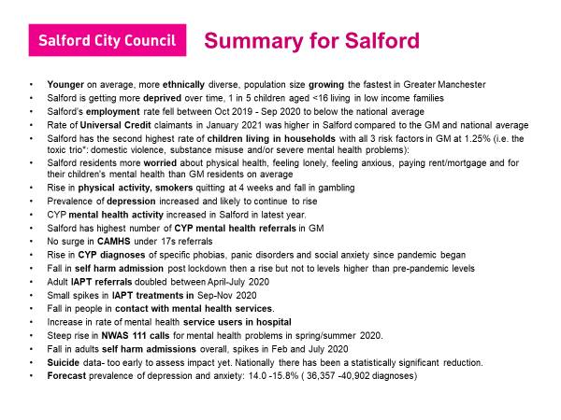

**Service Data monitoring**

Despite system-wide pressures, services have continued to provide quarterly reports where possible, as well as ad hoc additional information to local and GM commissioners to provide assurance and intelligence around COVID and service demand/capacity and to inform business cases for additional investment and new areas of development such as the ‘Parachute team’. Greater Manchester Assessment and In Reach Centre (GMAIC) has provided regular reports on Salford Tier 4 admissions which is shared with Social Care, Childrens’ Commissioning, Complex Needs and Safeguarding leads for both the Council and CCG to inform our multi-agency panel (MAP), CETR and MALM meetings to support improved co-ordination of care planning. This has helped improve the links between GM Crisis Care pathway and local service leads and is beginning to improve care planning, discharge and transitions plans and outcomes for young people

Close monitoring of waiting times and waiting lists remains a priority. Greater flexibility of some services during the pandemic has meant that referrals and young people awaiting treatment or in treatment have dipped in and out of provision, with some opting to pause treatment or decline services, whilst others have sought to shift to drop ins and check ins on switch to online support. This intelligence around young people’s preferences will be invaluable in supporting future commissioning and service delivery plans and will inform whether further investment maybe needed as well as service redesign – what we want to keep versus what we may want to stop doing. As a result of this learning, we are introducing brief interventions in a number of services to provide alternative options for young people to longer terms therapies which tend to have longer waits. There has been development and strengthening duty and assessment functions in many services to facilitate assessment of need and risk and to support prioritisation of support for complex and urgent cases.

The GM tableau report is updated and provided by the GM Health and Social Care Partnership and is the key document we use to monitor our progress on access and waiting times standards and National Key Performance Indicators (KPIs) in Salford, across GM and bencharked to national performance. This report is reviewed and monitored by the GM Long Term Plan Implementation Group (GM CAMHS Commissioners) and at the dedicated GM Data Club. We also share the GM report with the Thrive Partnership and Thrive Quarterly Oversight Group. See Sections 4 and 7 for more information about Tableau and performance monitoring.

**#BeeWell**

#BeeWell is a Greater Manchester wide programme, running an annual survey that measures the wellbeing of young people. The programme runs as a partnership between the University of Manchester, Greater Manchester Combined Authority and the Anna Freud Centre. The survey itself was designed by over 150 young people at 14 pathfinder schools, to include the questions that were most meaningful to young people. #BeeWell measures a wide range of domains and drivers that young people told us impacted their wellbeing, including their emotions, access to culture and sports, their relationships, their thoughts for the future, and many more. The survey will run every year, from 2021-2024, and schools receive annual, individual reports on the survey results to begin and strengthen their response to pupil wellbeing.

In Salford, almost 63% of pupils at participating schools completed the survey. This was represented by 1502 responses from Year 8 pupils, and 1365 responses from Year 10; meaning 60% of Year 10 pupils and over 65% of Year 8s have shared their views with #BeeWell. Now, the results of the first annual #BeeWell survey have been published on a school and neighbourhood level. Young people’s views on wellbeing are being listened to, and they are leading the response in telling authorities where support is working well and where it should be improved.

In terms of feedback:

* Schools get confidential reports giving insights into their pupils at a cohort level (but which they can share onwards with partners at their discretion) in January 2022
* Localities will receive:
  + neighbourhood-level reports giving insights into young people’s experiences (based on residential postcode) and how they vary across the different neighbourhoods in Salford in March 2022
  + locality-level reports looking at trends across Salford as a whole
* There will also be thematic/inequalities reports that cover all of GM but look into particular issues or particular cohorts later in 2022. We’re collecting demographic info such as ethnicity, SEND status, EAL status, gender identity, sexual orientation – all of which will feed into reports the University will be producing in the months following the publication of the survey.

This data will be produced annually and the Year 8 cohort will be tracked through as they go into Year 9 and Year 10.

**Strategic review of children’s and young people’s counselling**

Salford City Council and CCG agreed the need to undertake a system wide review of counselling provision in Salford to inform future commissioning plans and investment. The scope for the review is outlined below. The Review start was intentionally paused due to COVID pressures but has been hampered with significant challenges and in 2021 it was agreed to re-commission and re-start the work in Spring 2022. Counselling remains a key element of the children’s mental health system, but concerns have been raised over a number of years about gaps in provision, and lack of a universal service for primary age children, pressures on existing commissioned services and inequality of access to support in schools which do not routinely employer a counsellor or fund provision. The review will provide aims to:

* form a picture of need for CYP counselling services in Salford
* determine whether current provision meets that demand
* provide recommendations that will inform future Council and CCG commissioning and investment plans for children and young people’s counselling in the future

The scope of the review will include the following:

* **General counselling:** Including commissioned provision in voluntary sector and/private sector and schools-based counselling procured directly via schools or in house staff / teams in schools / colleges / universities. We have a variety of commissioned providers working in Salford, including 42nd street and Place 2 Be which are commissioned to provide school-based counselling as part of the Thrive in Education (mental health support) Team. 42nd street are also commissioned to provide a city wide counselling offer for those aged 13-25 (both face to face and online delivery).
* **IAPT Step 2 provision** (for people aged 16+): delivered for CCG by Six Degrees. Psychological Wellbeing Practitioners (PWPs) delivering low intensity CBT for common mental health disorders such as mild or moderate depression, panic disorder or generalised anxiety disorder.
* **Counselling for CYP affected by a family bereavement (Gaddum / Hospices)**
* **Therapeutic support** for families supporting children with a life limiting condition / palliative diagnosis
* **OTHER non-commissioned provision** including local and national services available via open access e.g. online/helplines, or local targeted/chargeable provision in Salford. There are various provisions included here.
* **Commissioned provision in GM** that may be accessed by Salford young people, such as the GM Universities Mental Health Service and KOOTH online provision.

**Extended support for young people aged 16-25**

The Covid pandemic continues to impact this age group disproportionally and targeted work to support young people aged 16-25 remains a Thrive Partnership priority for 2022. The 16–25 working group has been re-established and agreed to continue with identified priorities and to include digital access/inclusion as a new priority. The priorities for the working group include:

**Priority 1:** Data: Understating the need/capacity needed to meet the need

**Priority 2:** Living Well – joint work between children’s and adults’ services

**Priority 3:** Vulnerable / target groups aged 16-25 – NEET, risk of NEET, hidden / missing YP, Young men and Care Leavers

**Priority 4:** Addressing the age restrictions/limitations of services in supporting beyond 18

**Priority 5:** Peer support approaches for YP aged 16-25

**Priority 6: (**NEW agreed additional priority) - Digital inclusion /exclusion

Currently 42nd Street and Six Degrees are commissioned to provide mental health support across this age range, with 42nd street covering young people aged 13-25 and Six Degrees supporting those aged 16+. Online support is particularly popular amongst 16 – 25s with 72% of 42nd street online users being in this age group. KOOTH current offers online support up to age 18 but GM Health and Social Care Partnership are considering extending this up to age 25 in 2022.

Salford's implementation of the Living Well programme presents the opportunity to rethink how we support young people in this age group and families (parents and children) and to encourage joint working across commissioned services for children and adults. For more information on Living Well see page 21.

42nd Street has been commissioned by GM HSCP to involve young people in a ‘Young Adult Living Well Project’ to shape the Young Adult Elements of the Community Mental Health Transformation Programme. This commission acknowledges the need for Young adults to be recognised as having specific and targeted support as they transition into adulthood and was identified in Youth Access’s report with the DfE “Young People in Mind” focused on access to help and support for those aged 16+ years, particularly at points of transition. In this context, transition includes the multiplicity of transitions young people make as they move to adulthood.

The workstream will be co-produced at all levels with young adults, building on the already established GM wide BeeHEARD social action network. The work will be centrally resourced and led, connecting into each early implementer through new Young Adult Peer Coaches and workers.

The Young Adult Living Well Project will establish draw on the literature, GM good practice and personal experiences of young adults in Greater Manchester to deliver the following outcomes:

1. The compelling case for effectively meeting the needs of young adults within the community MH developments will be clear
2. All localities will utilise the Project Recommendations to ensure that the needs of young adults are effectively met within the community MH framework developments. To support this localities will be able to draw down support from Peer Consultants to facilitate creative workshops with young adults to co-produce the locality offer to meet the needs of young adults living in the locality
3. Localities taking forward Living Well developments will have access to recommendations in terms of timely access (e.g. Young Adult Can’t Wait Access to the PD pathway) and service acceptability, including workforce development recommendations. This may include recommendations for scaling and testing innovative approaches through seed funding.
4. The impact will be known through the development of a proposal for monitoring individual outcomes and system impact in the longer term
5. Recommendations will be made on next steps towards meeting the needs of 16 to 25 year olds such as embedding a needs led approach rather than age-defined limitations to services.
6. The ten localities will be able to evidence how their CMHF developments are effectively meeting the needs of young adults. Depending on progress there may be need to extend the project to two or three years.

**Steps Ahead**

Steps Ahead is a CCG Innovation Funded project testing targeted support for Care Leavers who are over 18 to improve access to Primary Care and mental health services. More details on this are included under Ambition 2.

**AMBITION 6: Progress**



Back to Contents

**Our Priorities for last year were:**

* Develop a CYP Voice and engagement plan and ensure that young people are involved in our Thrive work, to include peer research and work with ‘excluded’ groups
* Deliver on the commitments to young people involved in the Seldom Heard event held in 2019, including improved access to services in venues that young people want to go to
* Continue to involve young people in shaping, designing and improving services (see also Ambition 4 Young Adults Living Well Project)

**AMBITION 6: Children and young people have a voice**

**care**

**Children and young people’s Voice and Engagement**

The CYP Voice and Engagement Group was re-established after a pause due to Covid pressures, to lead on children and young people’s voice and engagement plans with representation from Salford Thrive Partnership. The action plan continues to focus on the following priorities:

* Peer Support
* Co-production with young people
* CYP Voice

The group also has representation from the Listening Hub run by Salford Safeguarding Partnership. Strong links have been developed with the Listening Hub and a listening event is due to take place on 7th March with a focus on Emotional Health & Wellbeing link to the Thrive programme.

The BeeWell survey of year 8 pupils and Year 10 pupils across Greater Manchester run jointly by GMCA and Manchester University has now been collated. The outcomes of these surveys will first be shared with schools and education leaders and then neighbourhood data will be shared with Councils leaders by March. This survey has been well received with 40,000 young people completing this survey across GM. The survey will include information of ‘levers’ to improving wellbeing which will be used to shape and form future approaches to tackling emotional health and wellbeing. For more information on BeeWell, see page 26 above.

**Interactive School Drama Workshops**

In 2021, Odd Arts continued their annual delivery of the interactive drama workshop targeted at Salford secondary schools. The dramas are revised annually and co-produced with young people based on their issues of concern and are supported by our commissioned services, in particular 42nd Street.

Despite delayed delivery due to restrictions in schools, the 2021 programme engaged 18 schools / education settings across the city, including Barton Moss Secure Unit, Pupil Referral Units and a performance for Salford Youth Justice Service. The project was delivered to a total of 1060 young people.

The performance was welcomed back to the Beis Malka Belz Girls school, with two performances delivered to 200 students, building on the partnership developed in 2019 and the culturally acceptable version of the play which was delivered to teaching staff.

The ‘forum theatre’ aspect of the workshop worked really well, with young people volunteering to step in and try out solutions. Feedback for both school and students has been extremely positive, with young people, during the performance feeling safe to open-up about personal experiences about their own mental health experiences; with staff reporting that many of the pupils who usually found it difficult to engage, were able to interact and contribute to the workshop.

**Peer support / mentoring programme development**

Research of models of good practice and consultation was undertaken with Salford schools about what they already have in place and would like in the future to support children in schools. This work is now linked with the Thrive in Education programme. In 2022 the Educational Psychology Service is offering a pilot across three Salford schools introducing unenhanced peer mentoring programme and the role of Emotionally Friendly Settings, ‘Young People’s Champions’. The pilot allows for young people’s voice to be captured to inform what a whole school approach looks like in their setting.

**Young People’s participation**

Our commissioned service continue to involve young people in opportunities and participation groups to ensure they have a direct say in how services are delivered and improved. Young people get involved in designing materials and resources, making services feel more welcoming and more inclusive. Services include examples of participation in their quarterly reporting. some great examples of participation work are in included below taken from 2021-22 quarterly reports.

**Participation Case Study: CAMHS Emerge 16-17 Service**

CAMHS has been incredible busy working with service users in collaboration to ensure their voices are heard and they are involved with co-production at all levels

* The CAMHS CSU Website is out for its first 6 month run (young people, parents and carers have been consulted and co-worked with the CAMHS working group to develop the wording, visuals and lay out of the site, Young People have produced videos and content too. We are pleased with the results, which we believe provides an accessible and friendly virtual front door to MFT CAMHS <https://mft.nhs.uk/rmch/services/camhs/>
* We have now developed the face-to-face participation group with the Lowry to be face to face fortnightly - a way of supporting young people whilst on a waiting list/ or to step down/ is a way of looked after children engaging with CAMHS in a way they feel safe, if they have opted out of a treatment service.
* Young people have reviewed and amended local mental health psycho ed material
* Young People have set up a CAMHS Logo competition working group – ongoing, A young person panel is going to decide the winner (with prizes)

**Case Study:- CAMHS LGBTQ+ Young Peoples Experience**

* MFT CAMHS LGBQT Co working on cases with the Proud Trust / Trans Youth Groups.
* In June we Carried out a CAMHS Pride Road Show ensuring all our basis were LGBQT Friendly

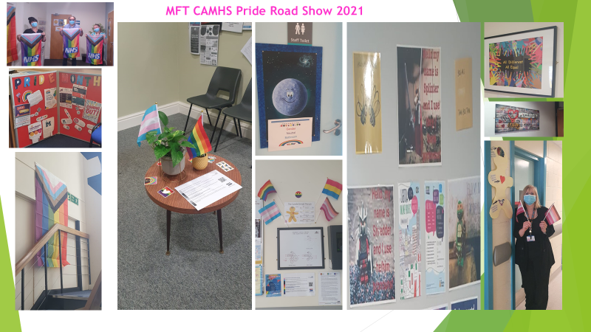

**Finance and Investment**

Back to Contents

From April 2019, Salford City Council and Clinical Commissioning Group (CCG) pooled budgets and established integrated governance and commissioning arrangements across adults, children and young people’s services, public health and primary care. It was envisaged that plans to integrate CCG and Council CAMHS budgets and contracts would have been implemented with effect from 1st April 2020, but this work was paused due to COVID, and both CCG and Council have continued to pay separately for respective commissioned services. However, budget planning and decisions relating to children’s mental health and wellbeing commissioning are now under joint governance and oversight and supported by joint work across CCG and Council finance teams. Transition to the new GM Integrated Care System is set to take effect in shadow form from April 2022 and if it not yet fully clear at the time of writing on how this will impact on local budget planning and management. In addition, and due to the pandemic, NHS England instructed all CCGs to pay NHS commissioned services on a block-based system rather than on locally agreed tariffs. Further NHSE guidance is awaited on future service funding arrangements, and this will determine when and how we are able to realise the plan to integrate CAMHS budgets and fully align children mental health budgets in the future.

Below is the forecast spend and forecast Investment plan for our integrated Thrive programme (CCG, Council and other funding) for this year (2021-22) and next financial year (2022-23). At the time of writing we are awaiting further guidance on budget allocations for children’s and young people’s mental health and have therefore assumed the same transformation budget as in 2021-22. Please note also that a number of these proposals have not yet been approved and are subject to Council/CCG governance at the time of writing.

**2021 -2022 Combined Investment**



@30.03.22 this includes: £6,167,951 CCG

**£6,571,466**

and £403,515 Salford City Council forecast spend

**2022 - 2023 Combined Investment**



**£6,344,823**

@30.03.22 this includes: £5,921,288 CCG

and £423,535 Salford City Council forecast spend

Please see Appendix B which includes a detailed breakdown of Salford’s spend to date and Investment plans for 2022-23.

**Performance, Outcomes & Service Data**

Back to Contents

Salford has continued to perform well against national / GM key performance indicators (KPIs) and these are monitored both locally via Thrive Programme Oversight Group and at GM level via the LTP Implementation Group (GM Health and Social Care Partnership children’s mental health programme leads and GM Childrens and Young People’s Mental health / CAMHS Commissioners) and via the GM Data Club. The following tables from the December 2021 GM Improving Access CYP Mental Health report provides a summary of the children and young people’s mental health KPIs and how we are doing compared to national and GM performance.

**Improving access to children’s mental health services**

The key performance indicator for improving access seeks to measure the proportion of children and young people with a diagnosable mental health condition that access NHS funded services. The national targets are set out in Table 1 below and show the target for 2020-21 was 35%. Improving Access to Children and Young People’s (CYP) Community Mental Health Support and Treatment is a key priority for Greater Manchester and Nationally, and table 2 below shows how GM performs well above both the Northwest and England averages, and that Salford performs well above all.

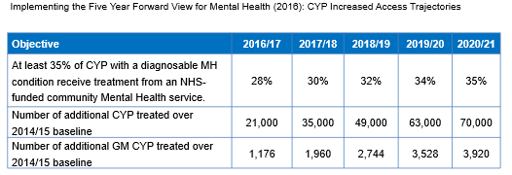**Table 1 shows the national target of 35% for improving access**

**Table 2 shows Salford’s and GM performance against the national targets**

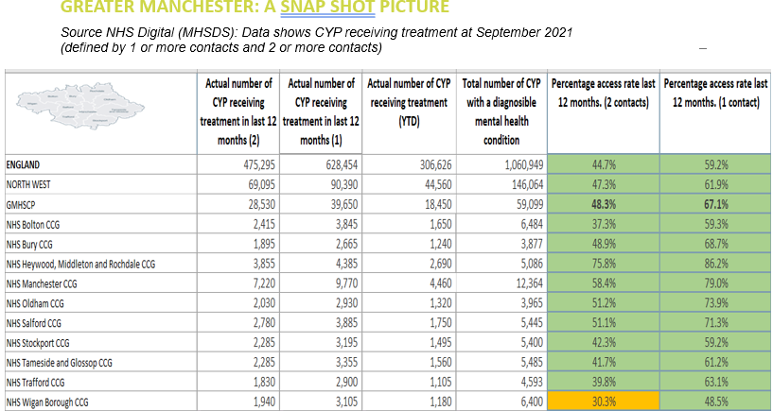

This KPI measure is expected to change in 2022 from a 2 to 1 contact access measure hence both are included in the above table for comparison. For Salford, this change would mean a 20.2% increase in access rate at 21.3%.

**Community Eating Disorder Services**

The national target is: By 2020/21, evidence-based community eating disorder services for children and young people will be in place in all areas, ensuring that 95% of children in need receive treatment within one week for urgent cases, and four weeks for routine cases. Salford continues to exceed requirements as can been seen in the tables below.

**Table 3 shows GM performance against the national targets**

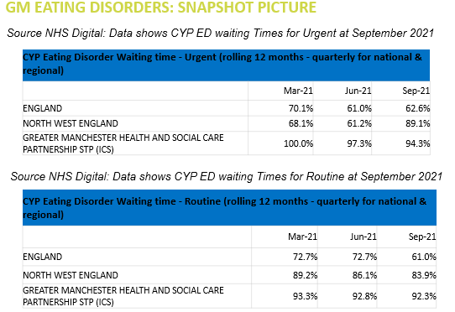

Table’s 4a and 4b below show Salford’s performance against other GM localities for both routine and urgent referrals, consistently achieving 100% performance against both targets.

**Table 4a: waiting times for routine referrals**

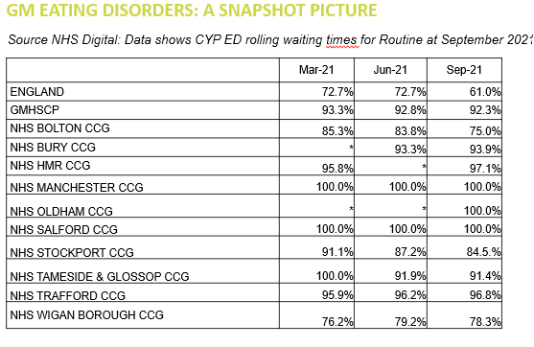

**Table 4b: waiting times for urgent referrals**

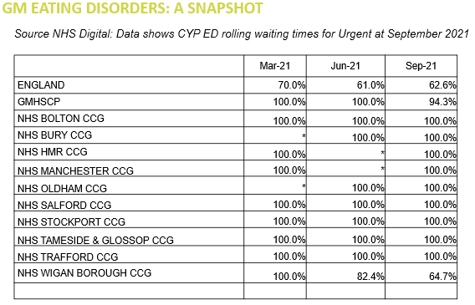

**Childrens Mental Health Waiting Times in Salford**

Improving access is underpinned by the timeliness it takes to receive support and treatment. Under the NHS Constitution, no patient should wait more than 18 weeks for any treatment. There is at present no specific national standards for waiting times for Children and Young People’s accessing Mental Health Services (CAMHS) except for:

* Patients with psychosis (two weeks)
* Those treated in the community for eating disorders (one week if urgent, otherwise four weeks. First contact must be within 24 hours in an emergency).

The Government's Green Paper on Transforming Children and Young People's Mental Health (2018) sets out an ambition to improve waiting times and seeks trailblazers to develop and test 4 week waits (4WW). Salford is not one of the 4WW pilots, but Trafford and Wigan are piloting this in GM and the learning from these will be cascaded.

Perhaps unsurprisingly there has been a general increase in waiting times across GM linked to service pressures during the COVID pandemic, and this is anticipated to worsen. In recognition of this there is increased investment both locally and in GM, especially in areas that experience the greatest levels of demand and longest waiting times such as for neuro developmental assessments.

It is acknowledged that the national indicators can and do mask so called ‘hidden waits’ such as for autism and ADHD assessments and some therapeutic support due to the prioritisation of young people with mental health needs, especially those with the highest levels of acuity (need), complexity and risk. This means that young people’s mental health and risk support takes precedence over other pathways and the waiting time performance is reflective of this. Young people who are not assessed as having co-morbid mental health needs will usually wait much longer for assessment and diagnosis, and post diagnostic therapeutic support. However, the needs of young people who are waiting is monitored and services will re-prioritise anyone needing more urgent care. Addressing the longer Neuro Development assessments waiting times remains a key priority for us and is being managed though our Neuro Development Pathway transformation work programme. A business case is currently in development which proposes additional investment to support pathway re-design and additional capacity across all services, including CAMHS. We hope that in time, this will help address the current longer waits for assessment.

Despite ongoing COVID pressures and the longer waits for assessment and diagnosis described above, for the second year in a row Salford CAMHS has managed to maintain a strong performance and, at the time of writing, we currently have the shortest average waits in GM for access to mental health support.

The three tables below show Salford’s CAMHS average waiting times to first and second appointments and from second to third appointment, compared with other GM localities between April – November 2021.

**Table 5 – shows average waiting times to first appointment by provider and CCG**

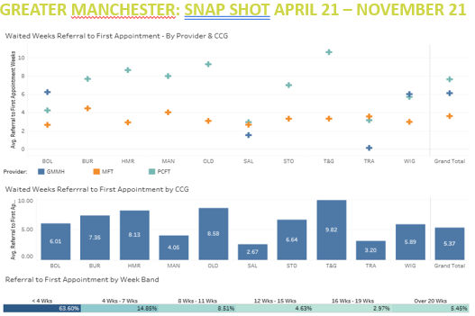

**Table 6: shows average waiting times to second appointment by provider and CCG**

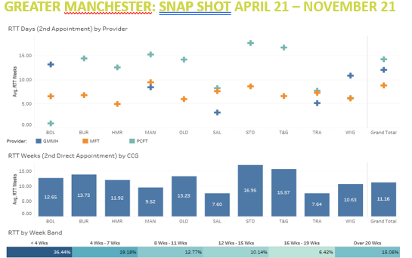

**Table 7: shows average waiting times from second to third appointment by provider and CCG**

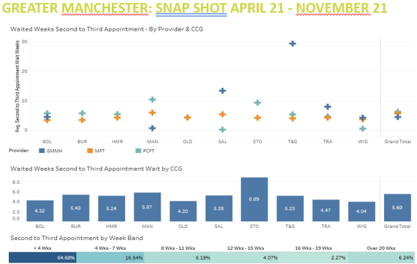

**Waiting Time pressures and levels of complexity in services**

Despite the good performance shown in the above tables, there remains some real pressure points in some parts of the children’s mental health system and linked to this, some children will experience longer waits for some pathways where capacity is most stretched and services may struggle to recruit and retain staff. This is especially the case for our multi agency neuro developmental pathway and in particularly for those referrals accepted into CAMHS for either assessment/diagnosis and/or co morbid mental health needs. GM have agreed additional funding to support CAMHS services to help manage demand and waiting lists from 2022 and locally this is a priority area for Salford which will result in a business case for increased investment to ensure appropriate capacity across the system where needed. This will span Early Help, screening/triage, multi-agency panels and assessment and pre/post diagnostic support encompassing CAMHS, Community Paediatrics, Speech and Language, and Educational Psychology and Parental Support.

In addition, and in recognition of the vulnerability of VCSE sector mental health provision and often the small teams employed within the sector, Salford and GM have invested more funding to support business continuity and to ensure accessibility of services. In particular, Salford has invested more funding in 42nd street and Gaddum to ensure service capacity to meet increased demand and greater complexity of referrals into counselling, online and psychosocial support services. GM has also continued to fund KOOTH to provide additional early help emotional health and wellbeing support across the sub region. The additional investment into 42nd Street has helped improve waiting times during 2021-22, bolster the duty and risk support function and to maintain the online offer. The increased investment into Gaddum has helped expand provision for young people and families needing bereavement support, from 6-8 young people per year before July 2020 to 35-40 families per year. Service reviews are being undertaken in 2022 to inform future commissioning intentions for these key services.

All our services continue to report high levels of acuity and complexity of presentations / needs, with increased risks and self-harm / suicidal ideation. This requires greater staff capacity and time to support and manage cases through duty and 1-2-1 therapy, often requiring extended support and flexibility to manage higher levels of risk. The main impact of this ongoing pressure is on tying up service capacity from accepting new cases/referrals, hence the challenge of managing reasonable waiting times. Combined with ongoing capacity issues related COVID isolation, sickness and general staff wellbeing, with significant difficulties in recruitment and retention in the mental health workforce, this remains the key challenge for all services.

Please Appendix D for more detail on Salford CYP mental health service data.

**Performance References and Links**

GM Provider Children and Young People’s Mental Health Services Dashboard: [www.gmtableau.nhs.uk/#/site/GMHSCPPublic/views/GMProviderLedCYPMHDashboard](https://www.gmtableau.nhs.uk/)

**Priorities for 202****1-22**

Back to Contents

In December 2021, the Thrive Partnership met to review the key achievements and challenges over the year and unsurprisingly it was agreed to roll forward existing priorities and continued focus on managing demand and capacity with regular review of service data and staffing. Covid impacts continue to influence service capacity and demand for mental health support, and to shape our funding plans to deliver business continuity, and to ensure children and young people can access the support they need when they need it. Risk support, service prioritisation, acuity and complexity, self-harm and suicidal ideation and crisis care / young people in distress will remain ongoing and cross cutting challenges and priorities in the next year.

Key programmes of work in 2022-23 include:

* Continued delivery and scale up planning of our Thrive in Education programme and blended mental health support team
* Scoping commissioning and investment plans for a GM-wide KOOTH online service
* Continuation of our 42nd Street online offer and service stability / re-design (subject to funding)
* Continuation of the Bereavement and Palliative Care Counselling provision delivered by Gaddum
* Further transformation of our integrated Neuro Development Pathway and securing additional investment to support this
* Recruitment of a CAMHS Parent Infant Mental Health Team, design and implementation of an integrated Perinatal and Parent Infant Mental health offer in Salford.
* Monitoring the implementation of our Transitions Policy and outcomes for young people
* Recruitment of Salford Trauma Informed Practitioners and embedding these into practice
* Implementation of our integrated children’s and young people’s mental health ‘Single Point of Access’, piloting this with GP referrals, then self-referrals.
* Scoping ways to link children and young people and parent/carers/families in with the Living Well programme and to ensure effective adult mental health advice and consultation within children’s services and multi-agency working
* Development and implementation of our ‘Parachute team’ pilot and using the learning in Salford to inform wider rollout in GM
* Improving access to mental health support for young people aged 16-25
* Restarting our children and young people’s voice and LGBTQ+ working groups and plans
* Continued delivery on National Targets/KPIs: 1) Access to mental health services and 2) routine/urgent access to Children’s Eating Disorder Services

**Key References / Links**

Back to Contents

* [Future in Mind](https://assets.publishing.service.gov.uk/government/uploads/system/uploads/attachment_data/file/414024/Childrens_Mental_Health.pdf)
* [Five Year Forward Plan for Mental Health](https://www.england.nhs.uk/wp-content/uploads/2016/02/Mental-Health-Taskforce-FYFV-final.pdf)
* [NHS Long Term Plan: Implementation Framework](https://www.longtermplan.nhs.uk/wp-content/uploads/2019/06/long-term-plan-implementation-framework-v1.pdf)
* [NHS Long Term Plan](https://www.longtermplan.nhs.uk/wp-content/uploads/2019/01/nhs-long-term-plan-june-2019.pdf)
* [NHS Planning Guidance](https://www.england.nhs.uk/operational-planning-and-contracting/)
* [NHS Mental Health Implementation Plan 2019/20 - 2023/24](https://www.longtermplan.nhs.uk/wp-content/uploads/2019/07/nhs-mental-health-implementation-plan-2019-20-2023-24.pdf)

**Appendices**

1. Salford Thrive in Education MHST Year One Evaluation Report (link) [Thrive in Education | Partners in Salford](https://eur02.safelinks.protection.outlook.com/?url=https%3A%2F%2Fwww.partnersinsalford.org%2Fsalford-0-25-advisory-board%2Fsalford-thrive-ehwb%2Fthrive-in-education%2F&data=05%7C01%7Cemily.edwards%40salford.gov.uk%7Cd41eb4a8b3ca40f5fa2908da28f5ecf3%7C68c00060d80e40a5b83f3b8a5bc570b5%7C0%7C0%7C637867333940289173%7CUnknown%7CTWFpbGZsb3d8eyJWIjoiMC4wLjAwMDAiLCJQIjoiV2luMzIiLCJBTiI6Ik1haWwiLCJXVCI6Mn0%3D%7C3000%7C%7C%7C&sdata=Rynw4FxlWbUHJx6GMz%2BwWV3VtJ0Mo%2F5wEy%2Fg5uTUDFI%3D&reserved=0)
2. Finance and Investment
3. Salford Children & Young People Mental Health Case Studies
4. Performance and Service Data